Segmentation Pre-processing
With Asymmetrical Blurring
By Timothy Bahls

Abstract:
I will describe a robust segmenting pre-processor I have implemented by improving methods worked on by D. Scharstein and R. Szeliski. The image will be iteratively blurred, increasing the differences between segments while decreasing the differences inside a single segment. The resulting image can then be segmented by rather simple segmenter because the results will be nearly completely segmented. This segmenter improves the speed and effectiveness of the blur by implementing a larger window size, and by segmenting a scaled version of the image.
Introduction:
I spent a summer working with by D. Scharstein and R. Szeliski, and I modified their segmenter. I was never very satisfied with it. My work in Modrian Motion required that the segmentation be nearly one hundred percent accurate. Since the only way to get acceptable results was to play with the parameters for each image, I didn’t feel that the segmenter was good enough.
Since then, I have coming up with ideas for improving both sides of the process. I’ve here present the revised segmenter with an explanation of how the algorithm works.

Motivation:
In order for segmenting to be useful in most real world applications, it needs to be fast and robust. That means that it shouldn't need individual parameters set for each image, a pre-determined number of segments, or the assumption that no two objects have the same color.

Problem Statement:
The basic idea of segmentation is to divide the image into equivalence classes. Given to pixels x and y, x and y are equivalent if the represent the same “piece” of the image.
Of course proper segmentation can’t be done unless we already know what each object is, so we need a shortcut. We work with these assumptions—any “piece” of an image is a uniform color and the pieces are relatively near each other. We may also assume that the region is contiguous or at least a certain size. The key idea is that sharp edges in the image mean sharp edges in the image.
However, we will not focus on the segmentation itself. Instead we focus on improving an image so that it can be segmented easily.
So what is an image that is easily segmented? It is an image where all the regions of color are uniformly colored and the edges between them are well defined.

Related Work
The segmenter I worked with earlier worked on a simple notion—for every pixel, we look at the neighbors. For each of the eight rotations, we compare the similarity of the four pixels nearest that side to the pixel. If the farthest of those has only a small color distance away, we assume it is in the center of a region. Thus the center pixel is assigned the average of all eight pixels next iteration. Otherwise we assume that it is on an edge. Thus the pixel is assigned the average of itself and the four nearest pixels. The algorithm does not try to deal with corner pixels—they are too few to worry about.

Theory
The ideal segmentation would be insensitive to noise—it would pick up no false edges. It would robustly handle large areas that have small edges. For example, a tree broken into leaves is little help at all, but if we can merge the leaves together, we will do much better. In that sense it should be very insensitive to edges.
However, it would also be pixel accurate—it would catch all important edges and would mark them exactly where they should be. For example, grass against rocks would be able to tell where each blade was and where the rock was between the blades. In sense it should be very sensitive to edges.
In the first sense, a very large window size could help us get the key picture much better—it would spread color more rapidly across the region, and it would ignore pixel sized discontinuities well. However, it would not be good for the second case. We add to this the challenge that large window sizes really increase run time dramatically.
However, we can take a hint from the fabulous work that has been done in scale-invariant computer vision—we rapidly can construct a scaled pyramid of the images. Keep in mind that segmenting on a small scale in a small widow is much like segmenting on a large scale in a larger piece of the pyramid. Thus we can use an effectively variable size window without compromising our run time.

Method
There are a few algorithmic difficulties that need to be worked out.
First, how do we divide our pixels if we use a window bigger than 3 by 3?
The next paragraph is for the mathematically inclined, we want to find a way to divide all pixels (except the center pixel) of an m by m window (with m odd) into eight approximately equal pieces. Since m is odd, there is some integer n such that m = n2 +1. Thus we want to divide m^2 -1 by eight.
m^2 -1 = (2n + 1) * (2n + 1) - 1 = 4n^2 + 4n = 4n(n+1)
Since either n or (n+1) is even, n(n+1) is divisible by 2 and 4n(n+1) is divisible by 8. That makes things easier.
Below is an even division of 3 by 3 and 5 by 5 window.
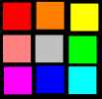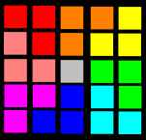
The results extend to an arbitrary (2n+1) by (2n +1) window. We first find four n by (n+1) blocks, one touching each corner of our window. Then we divide each of those two by the diagonal.
Once we have these eight regions, we can compute the first average by adding the first four sections. Then, to save time, we can merely add the next section and subtract the last section.
In fact, we can enhance our rotational accuracy with very little hit to run time this way—my algorithm uses an extension of the 8 rotations to come up with 24 rotations. It brings the edges into sharper focus—an important enhancement.
How do we handle edge pixels? Good question. For pixels that are along the edge, we can merely reduce the window where necessary and we can use a 1D modification for actual edge pixels. My implementation does not implement these ideas currently, however—it merely does not try to segment edges.
The most important question that remains is as follows: how do we use the segmented pyramid? We can start segmenting at the top. For each successive level, we can over lay the segmented version of the previous level over the current level with some constant alpha value. Currently, 70% is segmented from the higher level up and 30% is from the new layer. That means the “big picture” is solved at a high level in the pyramid, and more details are added piece at each successive level in the pyramid.
The code does not turn out to be terribly long.

Experimental Results:
In order to be fair, I’ve decided to include images that I choose once I was done tinkering with parameters. That is, these images are not chosen because they are good—they are chosen because they are hopefully representative:

Original: | Segmented:
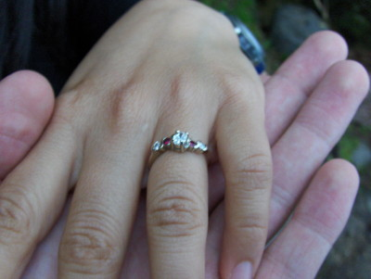 | 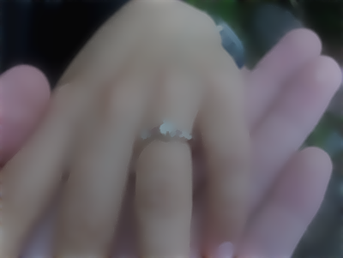
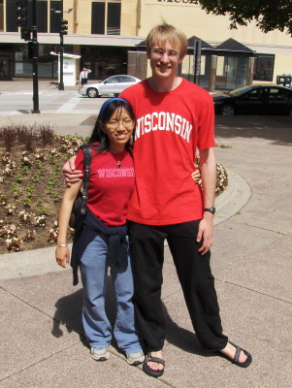 | 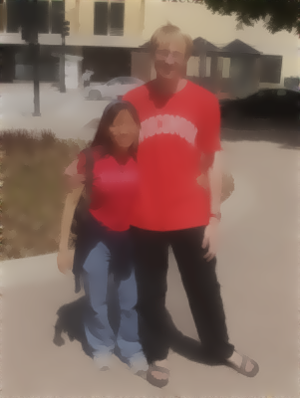
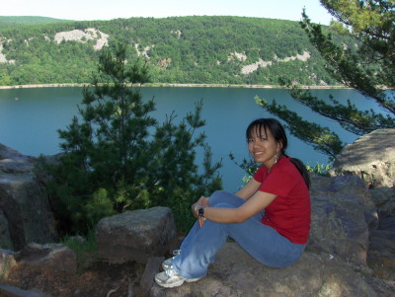 | 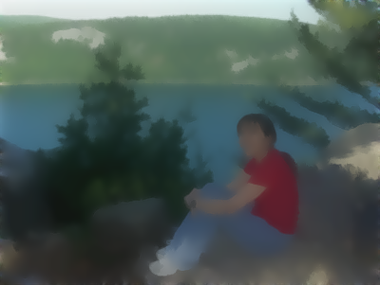
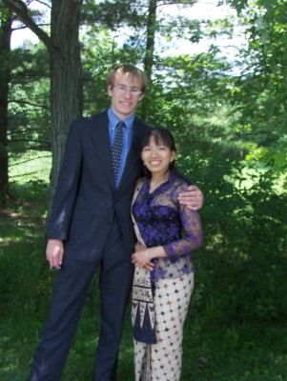 | 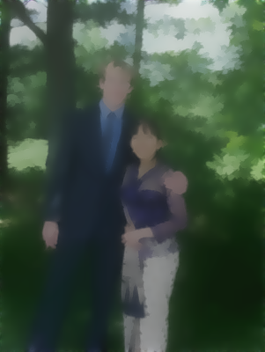
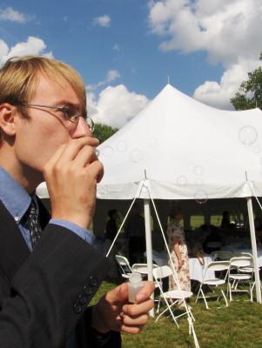 | 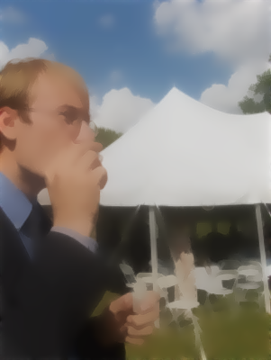
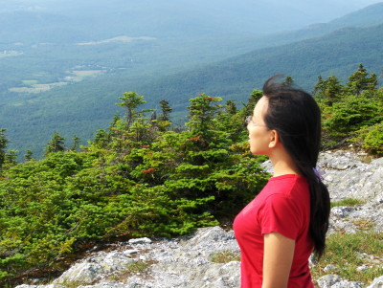 | 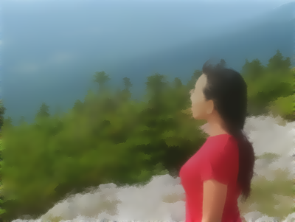
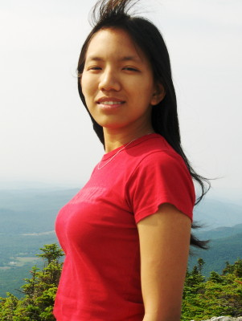 | 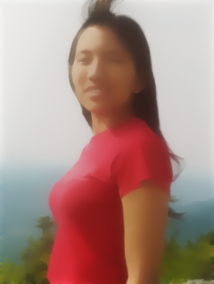
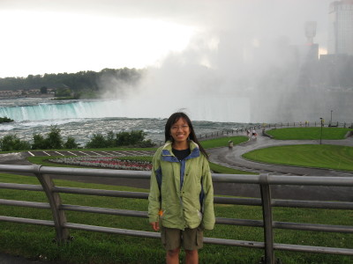 | 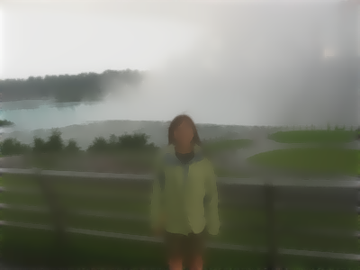

Here are a few things to note about the results:
*The results are only 7 iterations at each level. Coded in Java without a lot of clever tricks, the 400 by 301 images took a little over 69 seconds to preprocess total. That comes down to about eight and a half seconds each.
* The blurring at the smaller levels seems to reduce the overall saturation of the image. Since we are after the regions, and since we can preserve the original colors in the original image, I feel that this is acceptable.
*Some of the images could almost be mistaken for complete segmentations.
*Some very difficult textured regions have been handled gracefully, such as the wrinkles in the hands, the garden in the sidewalk, and the trees in the fancy dress picture.
*Some regions have not fared so well, such as the suit pants, the fence by Niagara Falls, and the green coat.
*Some impressive precision has been kept in the grass in the sidewalk garden and the windswept hair.
*My fiancée is beautiful.
*Despite the impressive results, the code is quite short—70 lines for an application, 70 lines for loading images and getting them in the right format, 100 for dealing with the pyramid, and 200 for blurring.
Concluding Remarks:
The improvement to the segmenter exceeded my expectations dramatically. I’m quite happy with how it turned out.

