Blood Cell Analysis Report (2006-02-02)

Xi Jing Hospital, Xi’an, China

No. | Term | Value | Reference Value | Unit
1 | WBC | 3.4 | 3.5-10.0 | X10E9/L
2 | MXD% | 0.193 | 0.05-0.12
3 | NEUT% | 0.65 | 0.5-0.7
4 | LYMPH% | 0.157 | 0.2-0.45
5 | NEUT# | 2.2 | 2.0-4.0 | X10E9/L
6 | LYMPH# | 0.5 | 1.0-3.3 | X10E9/L
7 | RBC | 3.82 | 3.45-6.50 | X10E12/L
8 | HGB | 102 | 115-180 | g/L
9 | HCT | 0.294 | 0.35-0.55
10 | MCV | 77.0 | 78.8-100 | fl
11 | MCH | 26.7 | 27-32 | pg
12 | MCHC | 347 | 300-360 | g/L
13 | PLT | 112 | 80-300 | X10E9/L
14 | MXD# | 0.7 | 0.2-0.7 | X10E9/L

(Note: Terms in red indicate abnormal value.)
Bone Marrow Test Report (2006-02-02)

Xi Jing Hospital, Xi’an, China

No. | Term | Blood  Film (%) | Marrow
No. | Term | Blood  Film (%) | (%) | Reference Value
1 | Myeloblast |  | 1.2 | 0.31-0.97
2 | Promyelocyte |  | 2.0 | 0.97-2.17
3 | Myelocyte |  | 6.8 | 5.93-9.87
4 | Metamyelocyte |  | 9.2 | 5.93-9.87
5 | Neutrophilic Granulocyte Band Form | 31.0 | 22.4 | 20.22-27.22
6 | Neutrophilic Segmented Granulocyte | 40.0 | 9.2 | 6.52-12.36
7 | Eosinophilic Myelocyte |  | 0.4 | 0.15-0.61
8 | Eosinophilic Metamyelocyte |  | 0.4 | 0.17-0.81
9 | Eosinophilic Granulocyte Band Form |  | 1.2 | 0.64-1.86
10 | Eosinophilic Segmented Granulocyte |  | 0.8 | 0.25-1.47
11 | Basophilic Granulocyte Band Form | 1.0 |  | 0.01-0.19
12 | Pronormoblast |  |  | 0.27-0.87
13 | Prorubricyte |  | 0.4 | 0.51-1.33
14 | Polychromatic Normoblast |  | 8.8 | 5.50-9.32
15 | Orthochromatic Normoblast |  | 19.2 | 8.39-13.11
16 | Primitive Lymphocyte |  |  | 0-0.14
17 | Juvenile Lymphocyte |  |  | 0-1.31
18 | Mature Lymphocyte | 5.0 | 14.0 | 15.74-29.82
19 | Mature Plasma Cell |  | 0.4 | 0.29-1.13
20 | Mature Monocyte | 15.0 | 3.6 | 2.12-3.88
21 | Heterotypic Lymphocyte | 8.0
22 | Primitive Megakaryocyte |  |  | 0-3
23 | Juvenile Megakaryocyte |  |  | 0-10
24 | Granular Megakaryocyte |  |  | 50-130
25 | Mature Megakaryocyte
26 | Naked Nucleus Megakaryocyte

(Note: Terms in red indicate abnormal value.)
Comments:

- The marrow is collected from the ilium bone.

- The ratio of granulocyte to erythrocyte (red blood cell) is 1.9.

- Granulocyte accounts for 53.6% in the marrow sample. The cell ratio is within normal range at all stages. A few myelocytes demonstrate imbalance in cell plasma development. Several granulocytes show chromatin and cell membrane dissolving.

- Erythrocyte account for 53.6% in the marrow sample. The ratio of orthochromatic normoblast is above the normal. Some of the red blood cells have small size, with less cell plasma. The division/segmentation of nucleus, as well as double nucleus normoblast, can be found in the marrow sample. The size of mature red cells varies. Some of the cells have light stain.

- The ratio of lymphocyte is below the normal. Heterotypic lymphocytes can be found in the marrow sample.

- Six megakaryocytes are found in the marrow sample. The platelet presents in scattered or clustered form.

- Heterotypic Lymphocytes account for 8% in the blood film. Single-nucleus and band-form granulocytes are observed. The size of mature red cells varies. Some of the cells have light stain. The platelet presents in scattered or clustered form.

ECG Report (2006-02-04)

Xi Jing Hospital, Xi’an, China

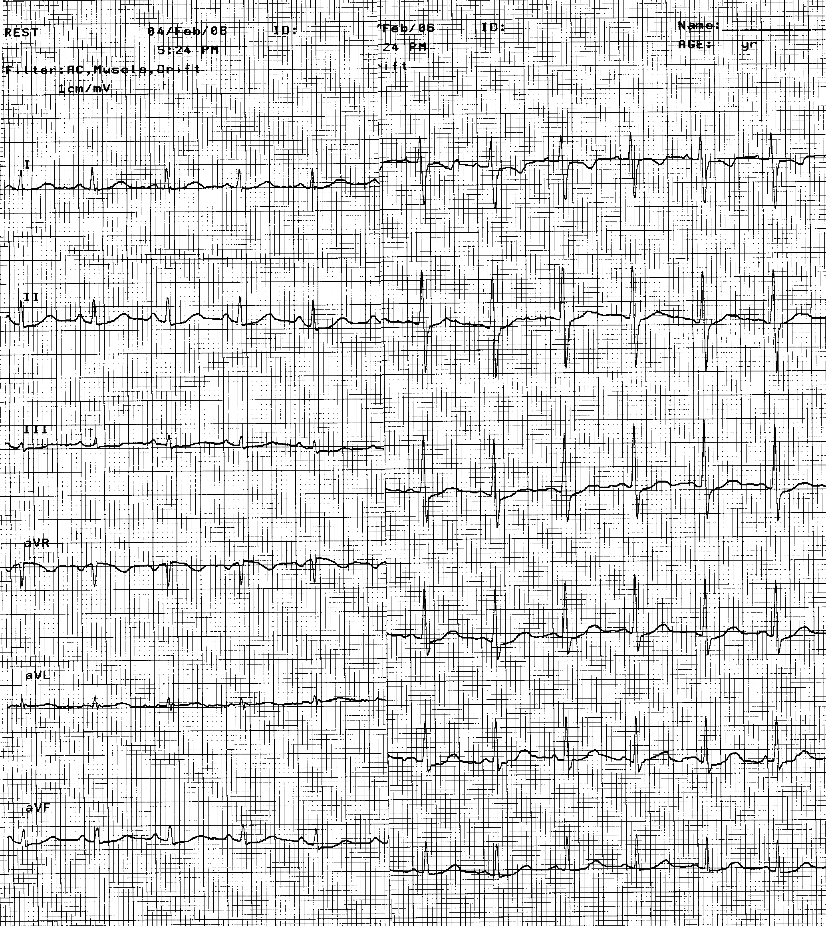

Comments:

ECG shows normal.

Biochemical Test Report on Liver Function, Kidney Function, Blood Sugar, Triglyceride, LDH, etc. (2006-02-05)

Xi Jing Hospital, Xi’an, China

No. | Term | Value | Reference Value | Unit
1 | ALT | 13 | 0-40 | IU/L
2 | AST | 13 | 0-40 | IU/L
3 | TP | 52 | 60-87 | g/L
4 | ALB | 31.5 | 37-55 | g/L
5 | G | 20.5 | 23-32 | g/L
6 | TBIL | 12.9 | 6.0-19.2 | umol/L
7 | DBIL | 7.2 | 1.7-6.8 | umol/L
8 | IBIL | 5.7 | 6.8-12.0 | umol/L
9 | ALP | 67 | 15-121 | IU/L
10 | GGT | 9 | 0-52 | IU/L
11 | TBA | 7.0 | 0.0-15.0 | umol/L
12 | LAP | 24.2 | 30-70 | IU/L
13 | A/G | 1.54 | 1.5-2.5
14 | AST/ALT | 1.00
15 | BU | 2.4 | 2.8-7.2 | mmol/L
16 | CRE | 58 | 53-125 | umol/L
17 | GLU | 7.2 | 3.9-5.8 | mmol/L
18 | LDH | 335 | 120-240 | IU/L
19 | HBDH | 294 | 76-218 | IU/L
20 | K | 3.90 | 3.5-5.6 | mmol/L
21 | Na | 143.8 | 135-145 | mmol/L
22 | Cl | 104.8 | 96-110 | mmol/L
23 | Ca | 2.14 | 2.0-3.0 | mmol/L
24 | CO₂ | 25.9 | 18.2-30.0 | mmol/L

(Note: Terms in red indicate abnormal value.)

Blood Cell Analysis Report (2006-02-05)

Xi Jing Hospital, Xi’an, China

No. | Term | Value | Reference Value | Unit
1 | WBC | 2.37 | 3.5-10.0 | X10E9/L
2 | NEUT% | 0.592 | 0.5-0.7
3 | LYMPH% | 0.139 | 0.2-0.45
4 | MONO% | 0.257 | 0.03-0.08
5 | EO% | 0.008 | 0.02-0.05
6 | BASO% | 0.004 | 0-0.01
7 | NEUT# | 1.40 | 2.0-4.0 | X10E9/L
8 | LYMPH# | 0.33 | 1.0-3.3 | X10E9/L
9 | MONO# | 0.61 | 0.12-0.8 | X10E9/L
10 | EO# | 0.02 | 0.05-0.55 | X10E9/L
11 | BASO# | 0.01 | 0-0.01 | X10E9/L
12 | RBC | 3.25 | 3.45-6.50 | X10E12/L
13 | HGB | 85 | 115-180 | g/L
14 | HCT | 0.267 | 0.35-0.55
15 | MCV | 82.2 | 78.8-100 | fl
16 | MCH | 26.2 | 27-32 | pg
17 | MCHC | 318 | 300-360 | g/L
18 | RDW% | 0.156
19 | RDW | 47.3 | 37-54 | fl
20 | PLT | 85 | 80-300 | X10E9/L
21 | PDW | 19.6 | 12-18 | fl
22 | MPV | 12.3 | 4.0-12.0 | fl
23 | P-LCR | 0.438 | 0.15-0.45
24 | RET% | 1.75 | 0.5-2.5 | %
25 | RET | 0.0569 | 0.025-0.085 | X10E12/L
26 | LFR | 0.850 | 0.70-0.90
27 | MFR | 0.113 | 0.135-0.24
28 | HFR | 0.037 | 0.005-0.045

(Note: Terms in red indicate abnormal value.)
Erythrocyte Sedimentation Rate Test Report (2006-02-05)

Xi Jing Hospital, Xi’an, China

No. | Term | Value | Reference Value | Unit
1 | ESR (60M) | 9 | 0-30 | mm/hr

Liver Test Report on Hepatitis B & C
Surface Antigen (2006-02-05)

Xi Jing Hospital, Xi’an, China

No. | Term | Value | Reference Value | Unit
1 | HBsAg | 0.78 | 0.0-2.0 | /HP
2 | HBs-Ab | Negative
3 | HBeAg | Negative
4 | HBe-Ab | Negative
5 | HBc-Ab | Negative
6 | HBVprsl | Negative
7 | HCV | Negative

Urine Test Report (2006-02-06)

Xi Jing Hospital, Xi’an, China

No. | Term | Value | Reference Value | Unit
1 | RBC | 6.9 | 0-10 | /ul
2 | WBC | 8.1 | 0-10 | /ul
3 | EC | 12.4 | 0-5 | /ul
4 | CAST | 0.4 | 0-2.5 | /ul
5 | BACT | 2219.9 | 0-8000 | /ul
6 | Path. CAST | 0.2 | 0-0.5 | /ul
7 | X’ TAL | 1.1 | 0-10 | /ul
8 | SRC | 1.8 | 0-3 | /ul
9 | SPERM | 0 | 0-3 | /ul
10 | YLC | 0 | 0-10 | /ul
11 | Others | 87.8 | 0-0 | /ul
12 | Non-Lysed # | 3.9 | 0-50 | /ul
13 | Non-Lysed | 57.1 |  | %
14 | URO | 16 |  | umol/l
15 | Specific Gravity | 1.015
16 | PH | 6.0
17 | Vitamin C | 0 |  | mmol/l

(Note: Terms in red indicate abnormal value.)

Immunohematology Report on Serum (2006-02-06)

Xi Jing Hospital, Xi’an, China

No. | Term | Value | Reference Value | Unit
1 | C-Protein | 3.20 | 0-5.0 | mg/l

Blood Coagulation Test Report (2006-02-06)

Xi Jing Hospital, Xi’an, China

No. | Term | Value | Reference Value | Unit
1 | PT | 11.8 | 10.5-12.8 | S
2 | APTT | 29.9 | 26.8-37.5 | S
3 | FIB | 6.00 | 2.0-4.0 | g/L
4 | TT | 15.7 | 14.2-19.6 | S
5 | AT | 96.6 | 83-96 | %
6 | INR | 1.01 | 0.92-1.11

(Note: Terms in red indicate abnormal value.)

Stool Test Report (2006-02-06)

Xi Jing Hospital, Xi’an, China

No. | Term | Value | Reference Value | Unit
1 | Color | Yellow
2 | Character | Soft
3 | Blood | Negative
4 | RBC | 0 | 0-1 | /HP
5 | WBC | 0 | 0-3 | /HP
6 | Sudan III Dye | Negative

Ultrasound Report (2006-02-06)

Xi Jing Hospital, Xi’an, China

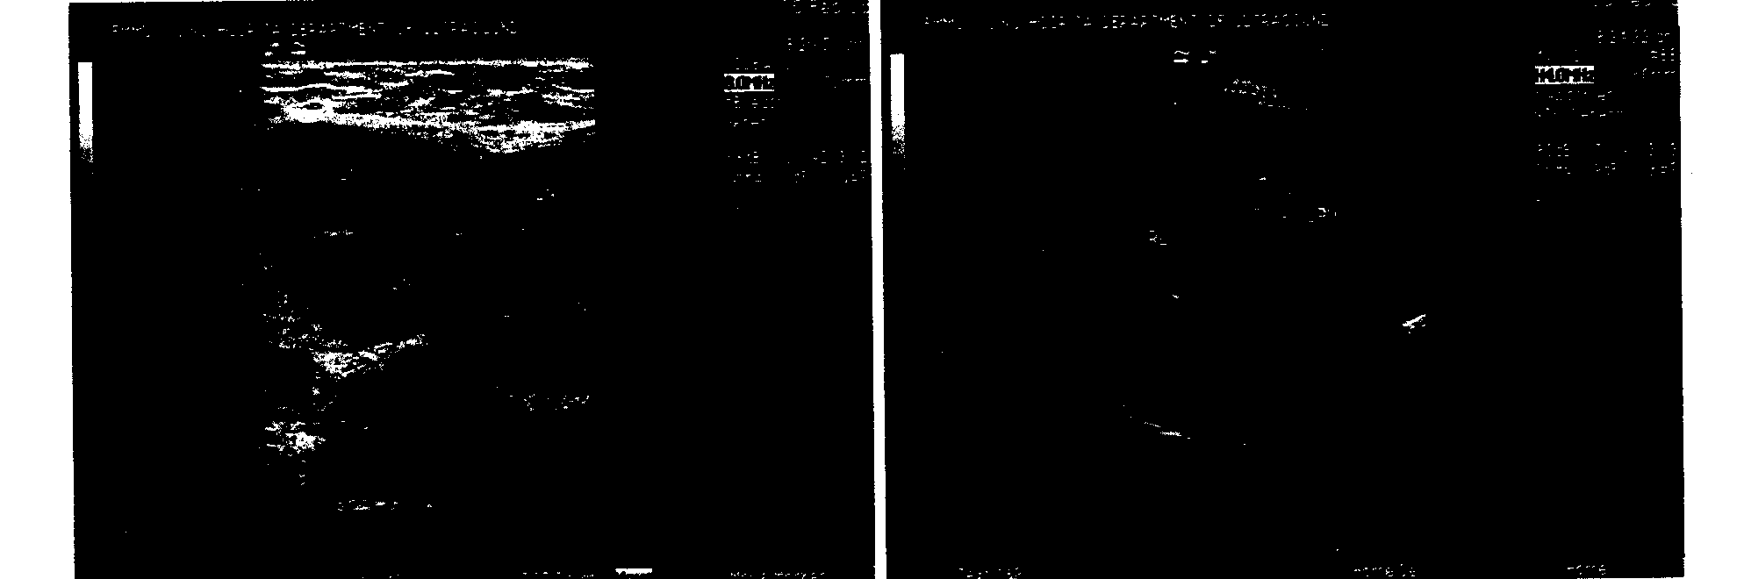

Comments:

- The liver, spleen, gall bladder, and kidney appear normal.
- There are multiple echo areas in the left armpit. The test shows the nodes are in elliptical shape, with some bonded together. The large one is measured to be 4.6 × 2.3 cm.
- There are also several lymph nodes identified in the right armpit. One of them is 1.2 × 0.5 cm.
- The inguinal glands are detectable on both sides, with clear boundaries and in elliptical shape. The one on the left side is 1.3 × 0.9 cm, while the one on the right side is 3.3 × 1.1 cm.

Bone Marrow Biopsy Report (2006-02-07)

Xi Jing Hospital, Xi’an, China

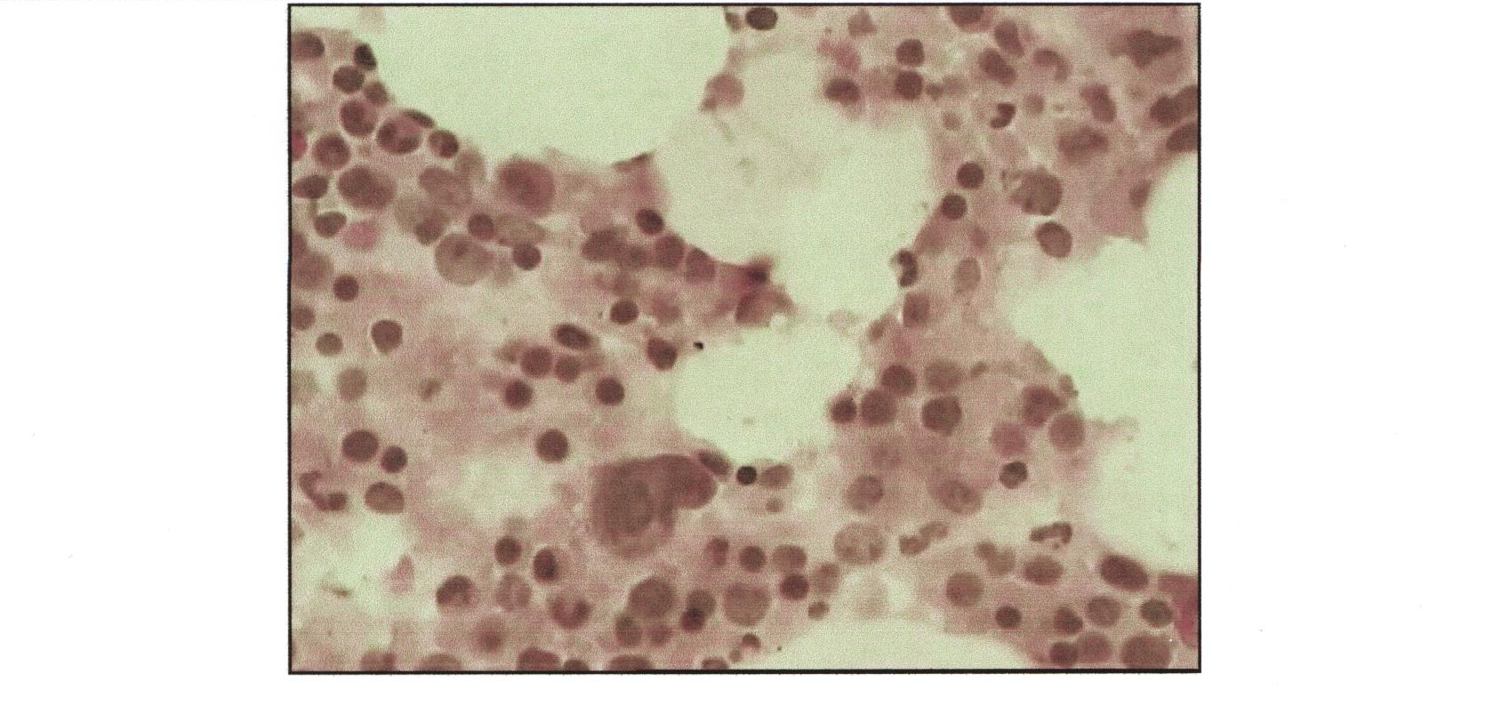

Comments:

- Eosinophilic myelocytes can be easily found.

- The bone marrow proliferation appears normal. There is no apparent abnormality in the shape and distribution of granulocytes, erythrocytes, and megakaryocytes.

- The number of lymphocytes is slightly above the normal. The cells are well-distributed, with various shapes & sizes. The cell plasma inside is less than average. Thus they could be identified as juvenile lymphocytes.

- The matrix is basically edema, with slightly proliferation of fibrous tissues.

Biochemical Test Report on Liver Function, Kidney Function, Blood Sugar, Triglyceride, etc. (2006-02-13)

Xi Jing Hospital, Xi’an, China

No. | Term | Value | Reference Value | Unit
1 | ALT | 14 | 0-40 | IU/L
2 | AST | 17 | 0-40 | IU/L
3 | TP | 45 | 60-87 | g/L
4 | ALB | 29.0 | 37-55 | g/L
5 | G | 16.0 | 23-32 | g/L
6 | TBIL | 14.1 | 6.0-19.2 | umol/L
7 | DBIL | 6.8 | 1.7-6.8 | umol/L
8 | IBIL | 7.3 | 6.8-12.0 | umol/L
9 | ALP | 59 | 15-121 | IU/L
10 | GGT | 7 | 0-52 | IU/L
11 | TBA | 3.2 | 0.0-15.0 | umol/L
12 | LAP | 21.1 | 30-70 | IU/L
13 | A/G | 1.81 | 1.5-2.5
14 | AST/ALT | 1.21
15 | BU | 3.1 | 2.8-7.2 | mmol/L
16 | CRE | 61 | 53-125 | umol/L
17 | GLU | 6.4 | 3.9-5.8 | mmol/L
18 | K | 3.4 | 3.5-5.6 | mmol/L
19 | Na | 144 | 135-145 | mmol/L
20 | Cl | 107 | 96-110 | mmol/L
21 | Ca | 1.9 | 2.0-3.0 | mmol/L
22 | CO₂ | 27.0 | 18.2-30.0 | mmol/L

(Note: Terms in red indicate abnormal value.)

Blood Cell Analysis Report (2006-02-13)

Xi Jing Hospital, Xi’an, China

No. | Term | Value | Reference Value | Unit
1 | WBC | 2.10 | 3.5-10.0 | X10E9/L
2 | NEUT% | 0.66 | 0.5-0.7
3 | LYMPH% | 0.11 | 0.2-0.45
4 | MONO% | 0.20 | 0.03-0.08
5 | EO% | 0.02 | 0.02-0.05
6 | BASO% | 0.01 | 0-0.01
7 | NEUT# | 1.39 | 2.0-4.0 | X10E9/L
8 | LYMPH# | 0.22 | 1.0-3.3 | X10E9/L
9 | MONO# | 0.42 | 0.12-0.8 | X10E9/L
10 | EO# | 0.04 | 0.05-0.55 | X10E9/L
11 | BASO# | 0.03 | 0-0.01 | X10E9/L
12 | RBC | 2.94 | 3.45-6.50 | X10E12/L
13 | HGB | 76 | 115-180 | g/L
14 | HCT | 0.23 | 0.35-0.55
15 | MCV | 79.9 | 78.8-100 | fl
16 | MCH | 25.9 | 27-32 | pg
17 | MCHC | 323 | 300-360 | g/L
20 | PLT | 77 | 80-300 | X10E9/L
24 | RET% | 1.79 | 0.5-2.5 | %
25 | RET | 0.0520 | 0.025-0.085 | X10E12/L

(Note: Terms in red indicate abnormal value.)

Pathology Report (2006-02-13)

Xi Jing Hospital, Xi’an, China

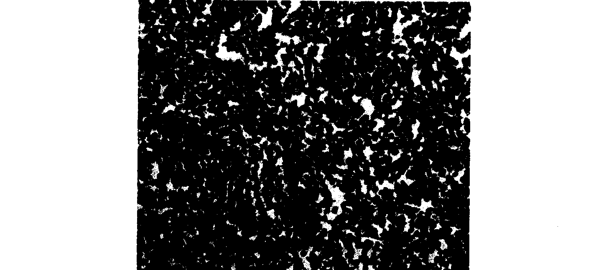
Microscopy picture.

Diagnosis:

Non-Hodgkin’s Lymphoma – lymphoplasmacytic lymphoma +

diffuse large B-cell lymphoma (CD20 positive)

