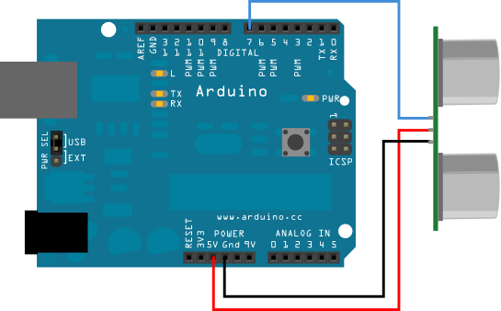

SIG (connect your SIG wire to digital input 9, 10, or 11 instead of 7)
VCC

How to wire your sensors to the Arduino Motor Shield

In order to connect your ultrasonic sensor to your motor shield, follow the diagram above. The pins of the diagram will match that of your motor shield.

- You will need to cut the sonar connector array in half and use each half for a different sensor.

- Splice the wires of the sonar connector array with the pin wires that were provided for you. The pin wires are used to plug into the pin slots of the Arduino board. I suggest using the same colored pin wire as the sonar connector array wire, black on black etc.

- It works better if you connect the SIG wire of the sensor to either pin slot 9, 10, or 11. Just make sure your code reflects this change.

- Connect the VCC pin wire to the 5V pin slot. If you try and use the 3V slot, your sensor will not have enough power to make an accurate reading. You can connect multiple sensors to the 5V slot by splicing them together or using the breadboard.

- Connect your GND pin wire to the GND pin slot. Notice that there are two GND pin slots, you can connect multiple sensors to this slot by either splicing them together and connecting the pin wire there, or using the breadboard.

