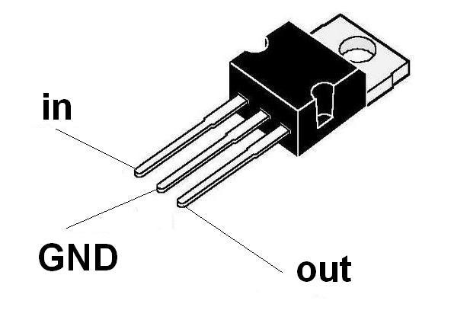
LM7805 – A voltage regulator that outputs +5 volts. Since the Arduino does not have enough power to control many servos at the same time, we use a different power source. The LM7805 acts as the power source for the servos, by regulating the voltage that comes in from the wall plug.

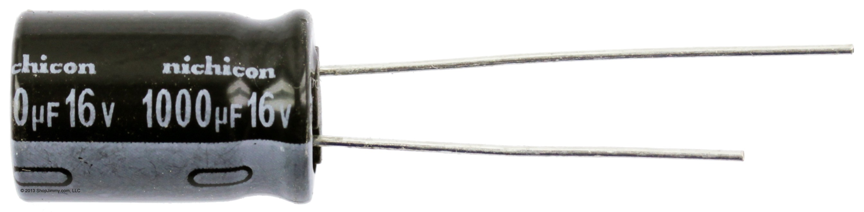
1000uF 16V Capacitor – A capacitor is like a storage device, it stores electrical energy. A capacitors storage potential is measured in units of Farads, which in this case is 1000uF. The capacitor in this circuit distributed the charge between the three servos that are being used.

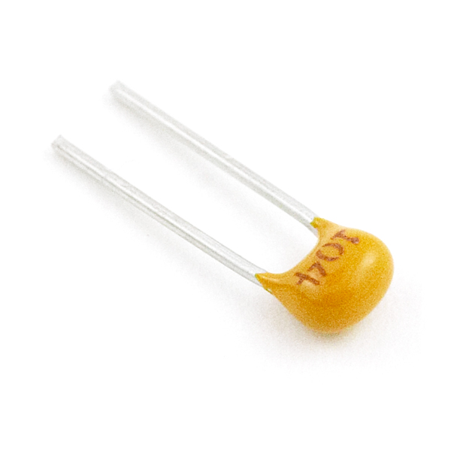

0.1uF Capacitor – A capacitor with storage potential 0.1uF.

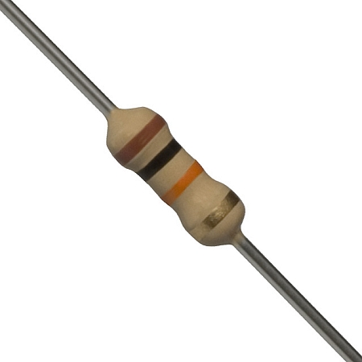

10k Ohm Resistor – A pull-up used to regulate the electric power entering a device. The basic function of the pull-up resistor is to insure that given no other input, a circuit assumes a default value. It allows the button it is connected to, to go from a LOW state to a HIGH state.

