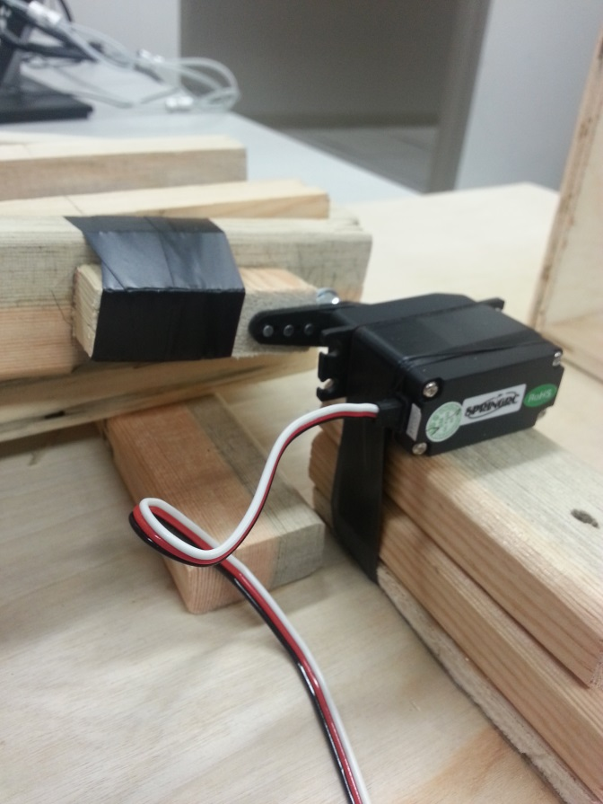
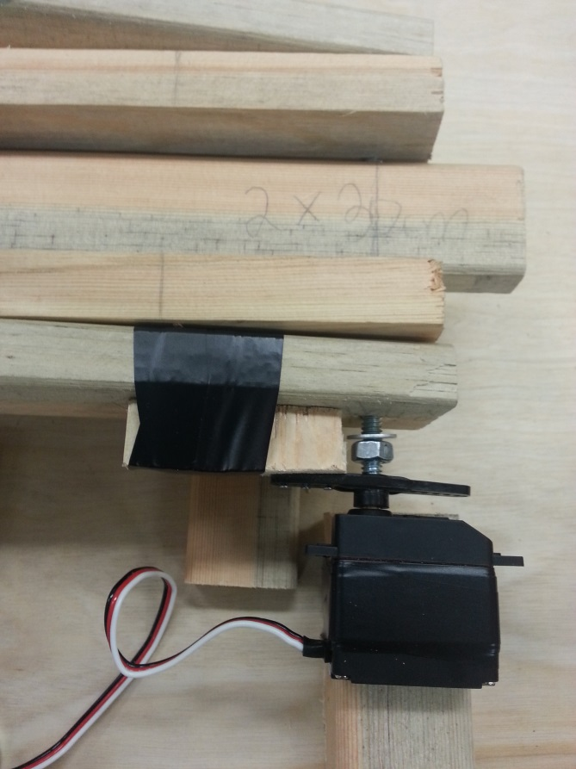
This servo will be used to control the angle of release. Use piece A to incorporate the servo that is controlled by the potentiometer. We have provided sufficient pins for you to do so. Make sure the pivot of the servo is lined up with the pivot of the catapult. This servo should be placed similarly to the picture above.
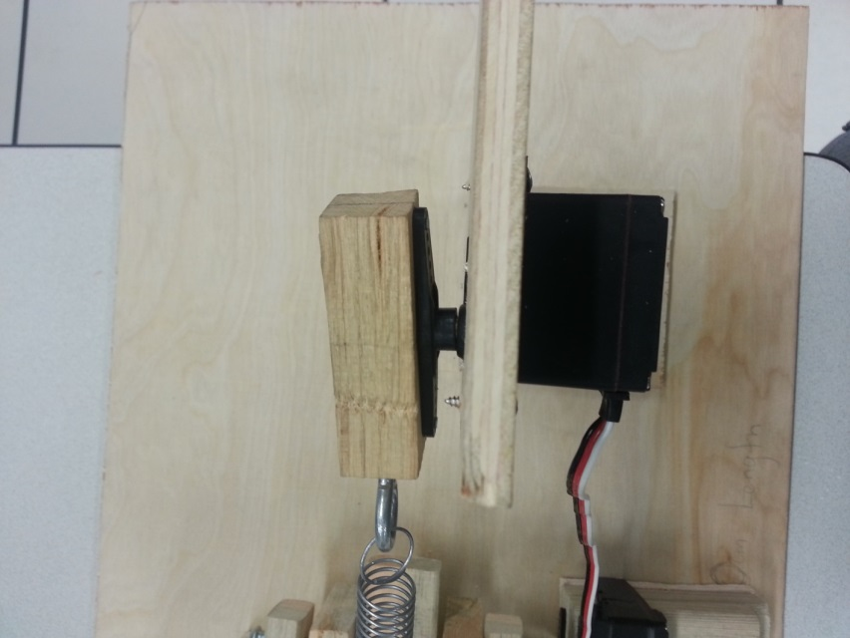
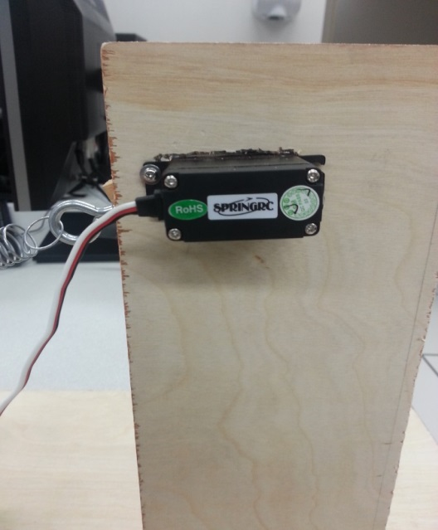
This servo will create the force that moves the catapult arm. Use piece B to incorporate one of the servos that is controlled by the button. Screw in the servo to piece B. Once the servo is attached to piece B, use pins to attach the servo pivot to piece C. Pass a screw through piece C in order to stabilize the pivot so that it does not come off every time you fire. Once you have the servo attached to pieces B and C, you should stick piece B to the base of the catapult. This part is really important, make sure you don’t stick piece B too far away from the catapult or else the servo will not have enough force to elongate the spring.

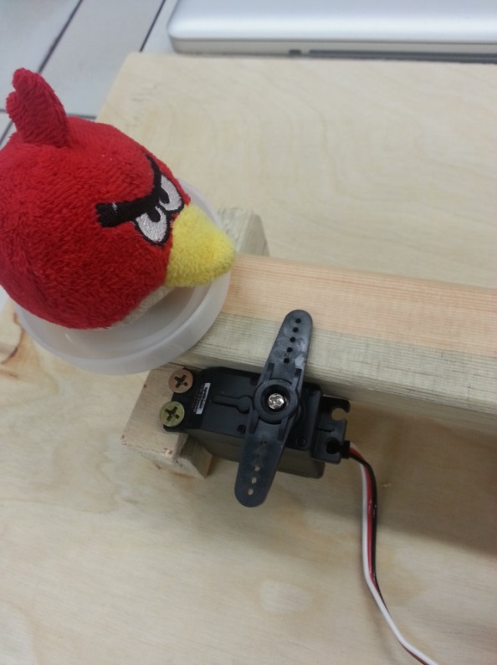

This servo will act as the trigger. Use piece D to incorporate the last servo, which is also controlled by the button. Screw in the servo to the little wooden piece that is stuck to the bigger one. As soon as that is completed, you should stick piece D to the base as seen in the image above.

