Wiring your Infrared Sensor

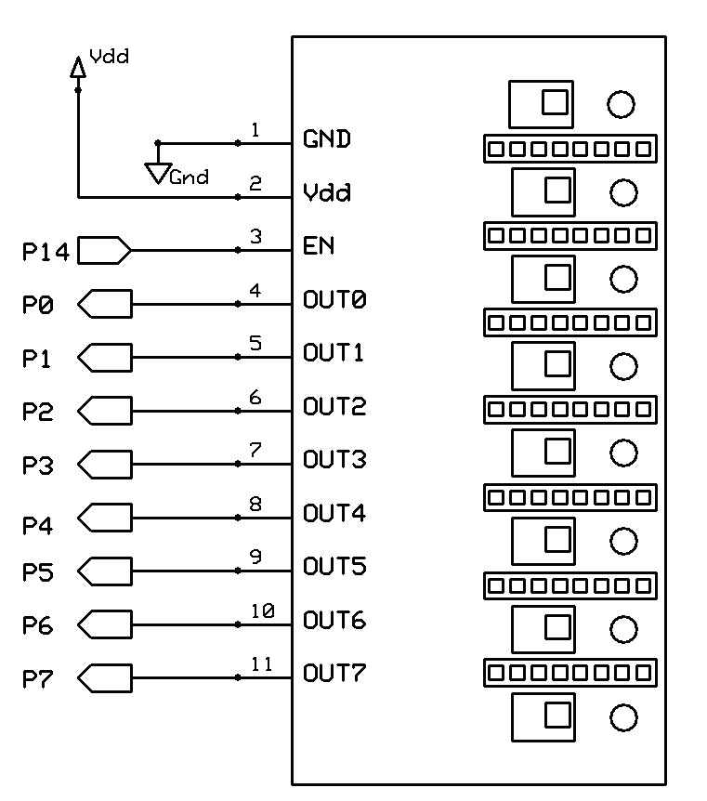
GND goes to GND on the motor shield
Vdd goes to 5V on the motor shield
EN goes to 3V on the motor shield
OUT0 goes to analog in 0
OUT1 goes to analog in 1
OUT2 goes to analog in 2
OUT3 goes to analog in 3
OUT4 goes to digital pin port 8
OUT5 goes to digital pin port 9
OUT6 goes to digital pin port 10
OUT7 goes to digital pin port 11

- Use the wire harness with the three wires – black, red, and white – to connect the GND, Vdd, and EN pins to the motor shield. I suggest using the black for GND and red for Vdd.
- Use the other two wire harnesses – blue, purple, grey, and white – to connect OUTs 0 through 7 to the motor shield.
- When writing your code, analog in ports 0 – 3 become digital ports 14 – 16 respectively. So just refer to them as such.

