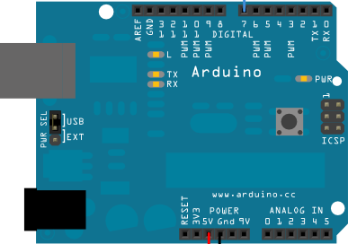

GND
SCK
MI
MO
CSN
CE
VCC

Wiring the nRF24l01 Radio Transceiver

- For this project, you will need two Arduino Boards. One board is going to be connected to the Radio Transceiver, and one board is going to be connected to the Touchscreen display. These boards will then be wired together in order to communicate.

- Connecting the radio transceiver to the Arduino Board
  - Using the square ended wires with both a male and female end, connect your radio transceiver to the Arduino board as shown above.
    - The GND and VCC that you use should be the ones that are on the same column as the CE, SCK, and MI terminals.
      - For more information on wiring the radio transceiver, visit maniacbug.wordpress.com/2011/11/02/getting-started-rf24/

- Connecting the radio transceiver Arduino board with the touch screen Arduino board
  - To connect this Arduino board to the Arduino board with the touch display, wire together the analog in ports, A4 & A5, and the non digital GND of each board using the round pin wires that came in your Arduino Starter Pack.
  - Strip one end of each of the three wires, this end will go in the pin ports on the board that the touch screen attaches on top of. Place the stripped ends of the wires in their respective pin ports, then connect the touch screen to that board so that the pins of the touch screen are in the same pin ports as the stripped wires. Take the ends of the wires that have not been stripped, a.k.a. still have their pins, and connect them to the pin ports of the Arduino board with the radio transceiver.
  - Make sure that A4 is connected to A4, A5 is connected to A5, and non digital GND is connected to non digital GND between the two boards.

