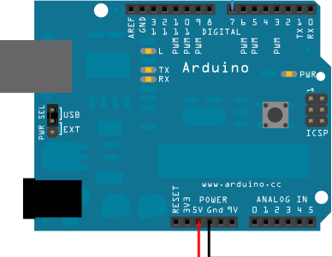
White wire to Pin 3
Yellow wire to Pin 2
black wire to GND
red wire to 5V

P.S.2 Keyboard Wiring Schematic

- Strip an inch or so of the keyboard’s wire housing to reveal the smaller wires inside.
- Connect each smaller wire to a pin wire from the Arduino Starter Pack
- Plug the wires into the correct pin ports as displayed in the diagram above, red to 5V, black to GND, white to digital pin port 3, and yellow to digital pin port 2 of the Arduino board.
- The colors of the smaller wires should be the same as in the diagram, however, your wires may not be white and/or yellow. If they are not, just test to see which of the two pin ports your wires go to by plugging them in one way, testing the code, and then if it doesn’t work, plugging them in the other way.
  - You should always have a red and black wire regardless of what color the other two wires are.
- After your keyboard is wired to your Arduino board, plug the Arduino into your computer using the USB cord, open the Arduino application, and run the Simple Keyboard example under file.
- You should be able to type on the keyboard and see the characters displayed on the Arduino’s serial monitor.

