Introduction
There are many cases of real-world problems that involve classification on data sets with a large input feature space and few examples. In these cases feature selection becomes very important. One such case is with proteomic data, where the data features collected for each example can number from 20000 to 60000 features. For classifiers such as Support Vector Machines, which map features into a higher-dimensional space, the number of dimensions becomes unreasonably high. Decision trees and Naïve Bayes already do a form of feature selection when trained on input-output values, but these algorithms can also benefit from a pre-selected set of features. [1] Having fewer features may imply less processing time, and less complex classifiers, which supports Occam’s Razor. [6]
Computational complexity explodes when using forward or backward feature selection. Every feature has to be tested at the first step, one less feature the next step, etc. [6] One effort to improve the search of the feature space is through the application of genetic algorithms. [1,2,6] Genetic algorithms are used to produce evolve individuals with genes which are, in the case of feature selection, a list of features that correspond to a subset of the feature space. A fitness function, which measures an individual’s performance on the training and tuning set, allows a parallel beam-like search of the feature space. [6] A broader search of the feature space may shorten the time needed to find a good subset of features. When compared to the hill-climbing approach of forward and backward selection, genetic algorithms provide a way to escape local-minima by allowing some randomness in the search through the mutation and crossover operators.
This report investigates a simple genetic algorithm as a feature selector, denoted as GA-FS, applied to a variety of traditional and modern classifiers. Filtering out irrelevant features from the concept domain may improve the classifiers’ performance in their ability to predict the class of present and future examples.
Problem Description
Genetic Algorithms
A genetic algorithm must be general enough to use arbitrary classifiers. It must be customizable enough to provide a measurement of the feature subset performance, called fitness using the genetic algorithm terminology. These calculations could include 10-fold cross validation, 90/10% random validation, and leave-one-out validation. For many classifiers there is a desire to learn parameters using tuning sets. This must be built into the genetic algorithms to allow for tuning across individual fitness functions.

Related Work
Genetic algorithms used as feature selectors are widely studied. This work differs in that the initial population size and the evolution time (in number of generations), for this experiment are much smaller (100 initial population size, 5 generations versus 1500 initial population size, 100 generations [2]), but the number of features is greatly reduced also. They also use a novel “lead cluster map”, which appears to be a private algorithm used in Proteome Quest by Correlogic, Inc. (see http://www.correlogic.com/) and based on Self-Organizing Feature Maps. [2,5]
Another such application is finding simpler decision trees by including into the fitness a measure of the number of tree nodes in a decision tree. [1]

Algorithm Description/Methodology

Basic Genetic Algorithm
A simple genetic algorithm is adapted from Holland’s book as listed in Table 1. [3] It is an iterative type of algorithm, generating a new child at each step. Each individual is defined as a string of feature indices sampled from the whole feature set. Selecting two parents and applying a single-point crossover operator generates a new individual. A single point crossover operator takes the feature indices from the first parent up to a randomly generated index and combines them with the second parent’s indices that come after the selected index. An example single point crossover is shown in Figure 1.
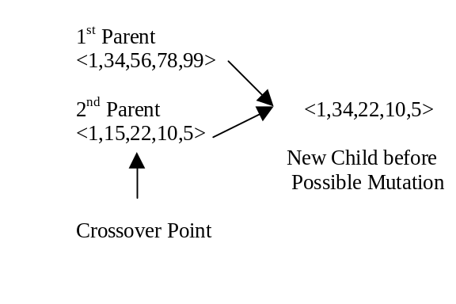
Figure 1 - Example Single Point Crossover operator using feature indices.
A mutation operator is coded to operate upon the newly generated child. Each feature index (or gene) in that child has a probability of being mutated, meaning a new feature index is randomly drawn from the full feature space. This allows for a broader search of the feature space by introducing new feature indices into the population’s gene pool. Mutation also prevents premature convergence, which promotes sub optimum solutions.
Duplicates of feature indexes are kept to allow a search of the space smaller than the set maximum feature length given by the individual number of genes. When an individual is tested for fitness, a new data set is generated for each of the training and validation sets that contain only the features in the individual’s feature index list. These data sets are then used in training and validation (see below). So an individual containing a duplicate would, by the way the conversion is encoded, would generate data sets having one less feature.
The parameters provided to control the search are the maximum number of features an individual can express, the number of iterations for the genetic algorithm, the population size, and the mutation rate. When a genetic algorithm is run, a new generation is produced when the number of iterations is a multiple of the population size. For example, a population size of 100 will have its first generation at iteration 100, the second at 200, and so on.

- H = population_size, I= Number of Iterations, N = Max Number of Features, P_{m} = mutation probability.
- Generate H individuals, with feature indices of length N.
- Score each individual -> U_{h}.
- Set i = 0.
- Randomly pick parent individuals p₁ and p₂ with probabilities proportional to their score.
- Apply simple, one point crossover, generating one new child c_{i} (use a random number to pick 1st parent).
- For each feature index in c_{i} determine if that feature should be mutated using P_{m}. If so, replace feature index with a randomly picked index from the pool.
- Calculate score of new child.
- Replace lowest scoring individual in population with new child.
- Increment i.
- If i < I goto 5.
Table 1 – Genetic Algorithm used for experiments in this paper.

Fitness function
The fitness function calculates the individual’s performance on the training set and tuning set. It is calculated by 10-fold cross-validation of the classifier on the reduced feature space derived from the individual’s feature index genes. Both the training and tuning scores are taken into account for each fold, using the function:

These scores are averaged over each fold. The average score ranges from 0 to 100. This metric provides a mechanism for allowing an individual’s fitness score depend upon the corresponding classifier’s score on both the training set and the validation set. The parameter α is adjustable, allowing control over the mixing of the two scores.
For tuning, a randomly selected 90/10% training/tuning set of the supplied training data is made.

Classifier Algorithms Used as Fitness Functions and Non-GA/GA Comparisons
The four classification algorithms described below are used as fitness functions for the genetic algorithm. They are also used to compare classifiers using the whole feature set versus classifiers using the genetic algorithm selected feature subset.
K-nearest-neighbor (KNN)
This algorithm basically memorizes the training set. [6] Upon classification, it calculates a distance metric between each unclassified example and the set of memorized examples. A set of K closest training examples is then used to determine the test example’s class through either a majority or weighted vote. The distance is calculated using the Hamming distance for discrete features and the following metric for continuous features:
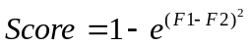
In this equation, F1 and F2 are the feature values of the two examples being compared.
The value of K is chosen using a tuning set. In this report, values of 1, 3, 5, 10, 25, and 50 for K are considered.

Naïve Bayes
Naïve Bayes is a probabilistic model that works by assuming that the example’s class is dependent upon each of the input features, but the features themselves are conditionally independent given the example’s classification. [6] The implementation of Naïve Bayes converts continuous features into discrete equidistant bins, using the minimum and maximum attributes of the feature. The number of bins used on the continuous features is tuned using 2, 10, 50, 100, and 200 as the possible number of bins.
SVM^{light}
The idea behind support vector machines is to map the data into N-dimensional space, where N is the number of input features. A set of separating hyper planes that best divides the data into the two (or more) classifications of the output class are found. [4] For the genetic algorithm approach, only linear mappings of the features were considered. Discrete features are mapped to a 1-of N mapping, where N is the number of values the discrete feature can take. This may introduce some irregular results, since the number of features will now also be dependant on the number of discrete features and the number of different values these features can take. For instance, a three valued discrete feature will be converted into three features, having (1.0,0,0), (0,1.0,0), and (0,0,0.1) as the different feature values.
One problem encountered with SVM^{light} is the inconsistency of optimization times for the training sets. Some of the training data required several days for SVM^{light} to converge. As a result, a time limit of 1 minute for training is imposed upon validation. This time limit presents a constraint on the fitness of the individual under study. If SVM^{light} times-out on a fold, the score is zero for both accuracies on the training and test sets. As the genetic algorithm proceeds, only the features allowing optimization within the limited timeframe will be selected. In the SVM world, this would correspond to selecting features that allow for easy linear separation in the feature space.
The c parameter that is passed into SVM^{light} allows for a trade-off between finding perfect separators, and increasing the margin for an imperfect separator. The value of this parameter is set to 50, to allow for imperfect separators with margins. The reason for this is again time constraints; we want the algorithm to converge in a reasonable amount of time. In the future, this parameter should be tuned to find the best trade-off parameter for SVM^{light}.
Decision Trees (C5.0)
The genetic algorithm is extended to use the decision tree algorithm presented by the program C5.0. [7] Since C5.0 automatically prunes the induced trees explicit tuning is unnecessary.

Experimental Parameters
The maximum number of features selected is set at 10. The selected value of α for the fitness function is 0.5. The population size is 100 and 500 iterations (or 5 generations) of evolution are performed. In each experiment the same classifier used for the fitness score is also the same classifier trained on all features and the GA-FS features for 10-fold cross validation. The data is obtained and pre-processed as defined in Appendix A.

Results
The jar-file of the classes used for this report can be found at http://www.cs.wisc.edu/~mcilwain/classwork/cs760/FinalProject/, along with a copy of this report. Java documentation for the packages can also be found there. Source code is provided upon request.
The results of the cross-validation and the features selected at each fold are tabulated in Appendix B. Statistical paired student t-tests for difference between all features and the GA-FS features are tabulated in Table II. The average 10-fold testing scores with 95% confidence intervals for all features and GA-FS for each of the classifiers are presented in Figure 3.
The frequency of each feature selected is graphed in Figures 4-7. The frequently selected features for each classifier are tabulated in Table III.
Evolution traces are displayed in Figures 8-11. These monitor the fitness score of the least, the best and the average score as a function of evolution iterations. 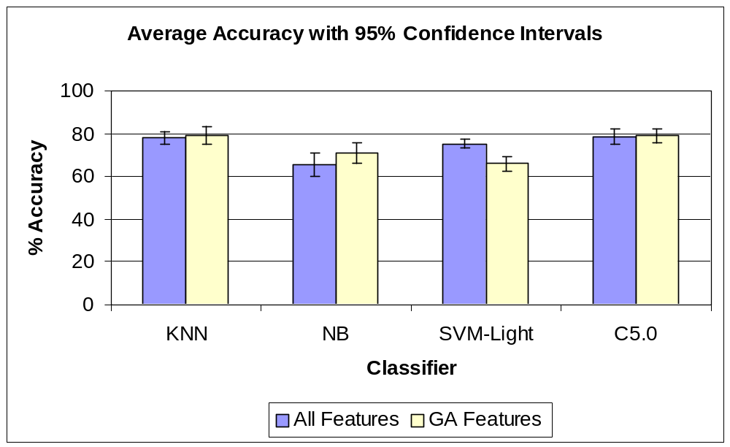

Figure 3 – Average Accuracy with 95% Confidence Intervals.

Classifier | All Features/GA-FS paired student-t test
KNN | -1.292 ± 6.126
NB | -5.082 ± 3.549
SVM^{light} | 9.501 ± 4.739
C5.0 | -0.667 ± 3.697
Table II – Significance Tests of All Features vs. GA-FS Features (calculated using paired student-t tests at 95% Confidence). A negative value is an indicator of GA-FS performing better than All Features, and vice versa.

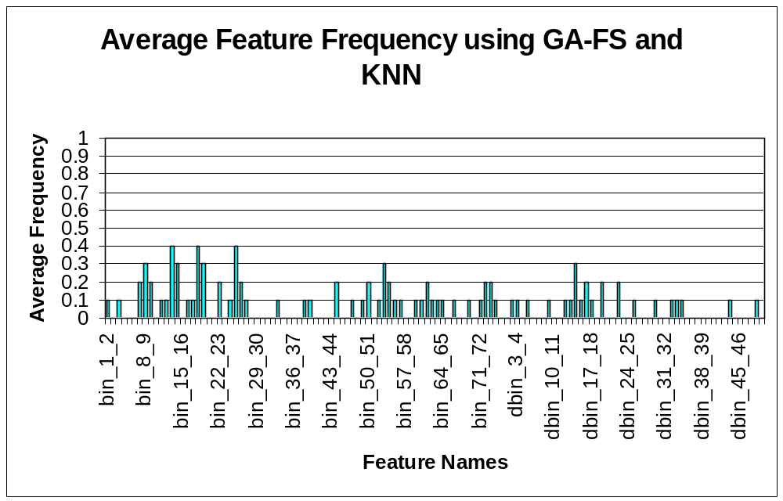Figure 4 – KNN Feature Frequency
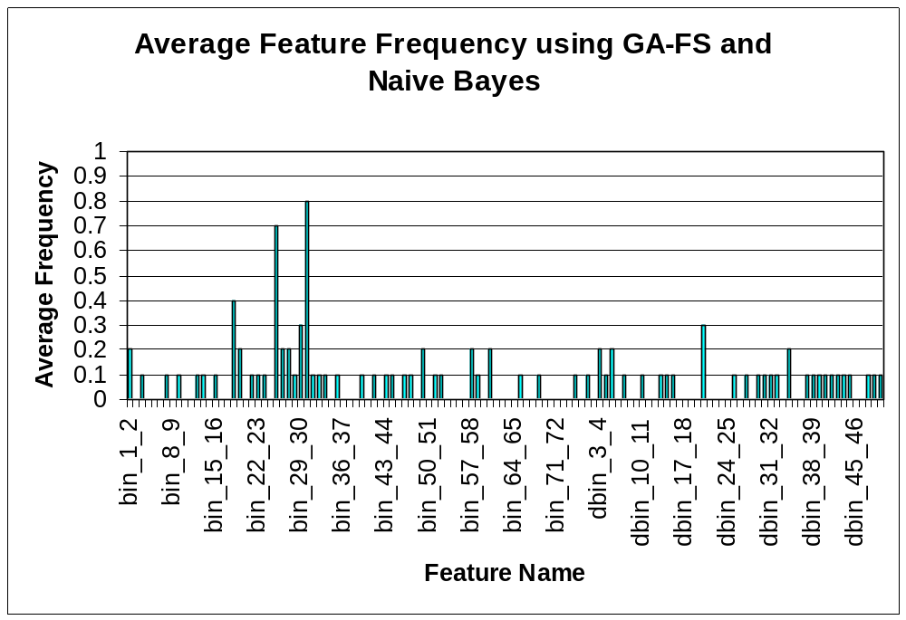Figure 5 – Naïve Bayes Feature Frequency

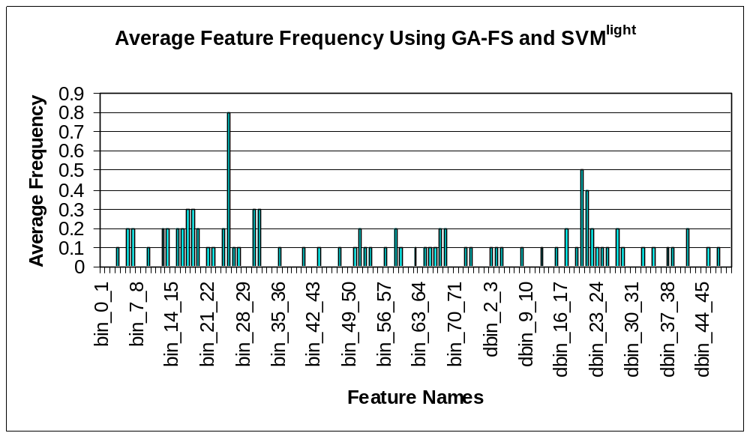
Figure 6 – Average Frequency of Features Selected Using GA-FS with SVM^{light}.
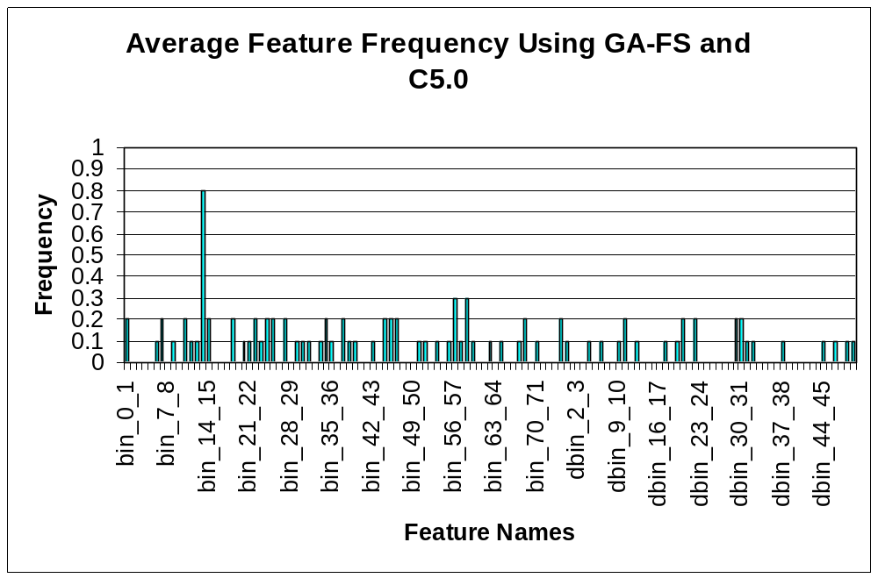Figure 7 – Average Feature Frequency for C5.0

 | KNN | Naïve Bayes | SVM^{light} | C5.0
Top Features (selected more than three times in ten folds). | Bin_13_14 (4) Bin_18_19 (4)  Bin_25_26 (4) | Bin_18_19 (4)  Bin_25_26 (7)  Bin_30_31 (8) | Bin_25_26 (8) Dbin_20_21 (5) Dbin_21_22 (4) | Bin_13_14 (8)

Table III – Top Features Selected Using GA-FS on KNN, Naïve Bayes, SVM^{light}, and C5.0. The number in parentheses is the number of times the feature was selected in the 10-fold cross-validation.

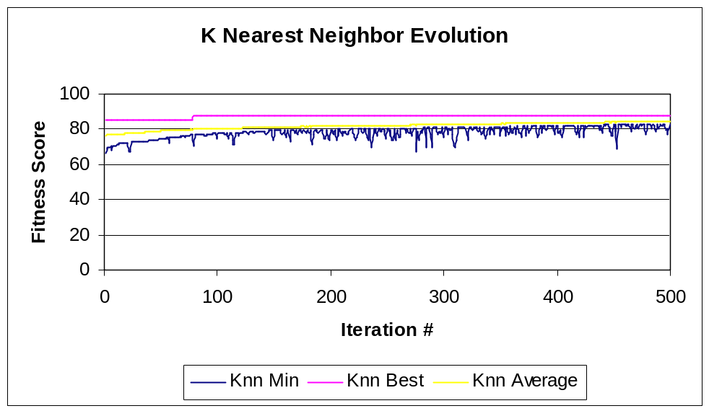
Figure 8 – KNN Evolution Chart
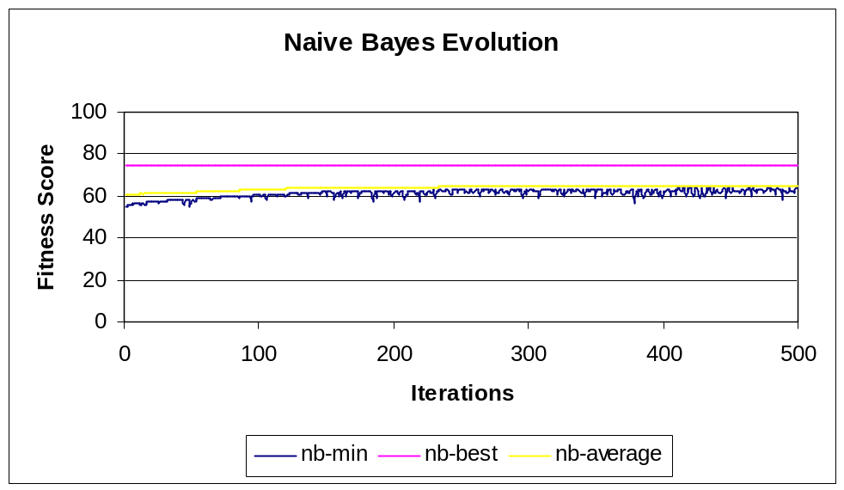
Figure 9 – Naïve Bayes Evolution Chart

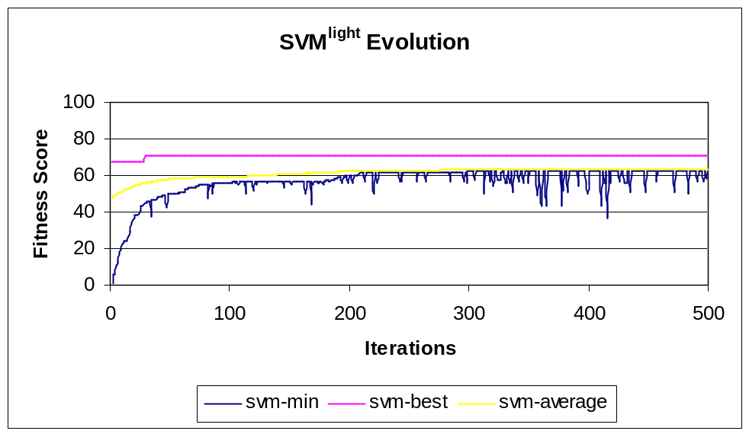
Figure 10 – SVM^{light} Evolution Chart
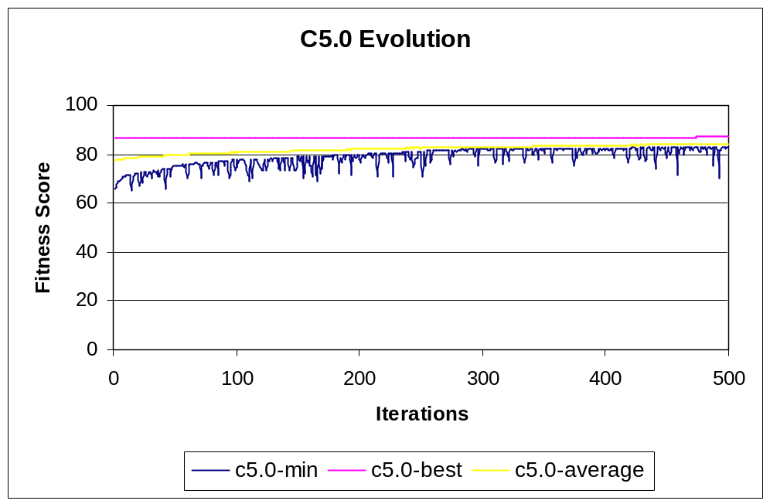
Figure 11 – C5.0 Evolution Chart
Discussion
With the exception of the Naïve Bayes and SVM^{light} algorithms, the performance of the classifiers using the features selected by the genetic algorithm did not have statistical significance in the testing set performance over the classifiers trained on all of the features. However, the genetically selected features are within a reduced feature space and does just as well as the same corresponding classifier trained on all features. This means that a large amount of irrelevant features can be removed without any significant change in future performance.
The improvement on Naïve Bayes with the selected features is promising, although also brings up an important feature about the data used in the calculations. The best number of bins that were selected at each fold are around 50-200. The dataset has most of the continuous features with numbers far below that of the maximum value. Most of the upper bins will never be used for the data set, so the classifier is more complex than necessary. Changing the algorithm to use bins with an equal number of examples in each bin or modifying the algorithm to use Gaussian probability density functions for continuous variables may address this problem. Another way is to pre-process the whole data set to obtain a better distribution of the continuous feature values.
SVM^{light} does statistically worse when using the GA-FS features. This may be due to the crude timeout solution to obtain results quicker. Other ways to improve upon this would be to tune the c parameter in SVM^{light}. Due to time constraints, this will be reviewed later.
Another issue involves the amount of time spent training and testing the classifiers to obtain fitness scores for each individual set of features. A way to alleviate this is to use a simpler and faster classifier as a scoring function for the genetic algorithm, and then training the classifier of interest using the selected features. Although, tuning within individuals could not apply, more evolution iterations could be performed in less time and may select a better set of features. Naïve Bayes or a decision tree would be a good choice as a fitness scorer, since they both learn and classify fairly quickly and, as a result, acquire fitness scores faster for the genetic algorithm.
Looking at the evolution traces, an interesting observation is made on the best-fit individual. The best-fit individual does not change very often, while the average and minimum appear to approach an asymptotic limit. This may be an indication of premature convergence, but also bring into question of whether a Monte Carlo algorithm may do just as well. Another problem may be the small population size, the small number of generations observed or a larger value of the mutation rate is needed to prevent premature convergence and obtain a more optimum score. More experiments need to be run to explore these possibilities.
While current algorithm gives the feature set that scored best on the given feature set, perhaps using multiple sets from other fit individuals in a bag algorithm may improve the overall results. This idea may reduce the readability of the composite features, classifiers learned, but also would allow other feature sets that scored well to provide their input. A similarity score would need to be introduced to make sure that individuals with the same feature set would not overwhelm the other individuals’ effectiveness.
Feature frequency charts are provided as an effort to provide some measure of the features most commonly selected across all cross-validation folds of the data. In the case of proteomic data comparing women with or without ovarian cancer, looking at items of biological interest within these prevalent features should help focus their attention to determine proteins implicated in the disease.

Future Work
Ten-fold, and jack-knife cross-validation is to be provided for tuning within the individual’s classifier. Since the training on certain classification algorithms take a rather long time to compute with tuning and 10-fold validation, such as SVM and KNN, these options were not implemented at the present time.
The boosted tree algorithm provided by C5.0 should be tested, along with using fitness scores to include the provision of tree complexity as in Cherkauer & Shavlik. [1] Also, boosted trees could be coupled with the GA feature selector, and will be done later to broaden the investigation of GA and feature selection.
With the preliminary results of this paper, the next step is to rerun the genetic algorithm on the data set using the feature and parameters used on the Clinical Proteomics Databank website. Since the “lead-cluster map” is not available on-line, Linear Vector Quantifier’s (LVQ’s) and other clustering maps will also be studied along with the algorithms listed in this report. [2,5]
Similarity scores of the individuals for parent and victim selection will be added in help reduce the problem of premature convergence. Applying negative scores on the generated children if the same individual(s) already exist in the population, will force them to be excluded from the parent selection, and increase their chances of being replaced by other children.
Using different classifiers for feature selection and training is already supported by the current version of the java packages. More experiments would have to be run using Naïve Bayes and/or C5.0 as fitness scorers during the feature selection to see if comparable results can be obtained.
Tuning upon additional parameters, such as c in SVM^{light} may be beneficial in improving upon the classifiers’ results on the GA-FS data set.
Another idea for a classifier would be that of a non-Naïve Bayesian network. Since the selection of the number of features is much smaller, it may be possible to enumerate all possible Bayesian networks using the GA-FS features and the output feature as nodes, and taking the best network that obtains the maximum probably of the training data given the network. This algorithm should be easy to implement as a new classifier and can be tested against the other classifiers’ performance.

Conclusions
Many questions still remain on whether GA-FS presents a significant improvement over classifiers using all features or if it performs better than the forward or backward feature selection algorithms. Other classifier algorithms are to be analyzed. The genetic algorithm presented here is operational and should be general and customizable enough to perform many more experiments using GA-FS with other classifiers. Future work will provide more development with the genetic algorithm as a feature selector in the ways of speed and fitness score accuracy. Looking at the features selected most frequently by the genetic algorithm across folds may help scientists focus their studies for biological insight into the provided data.

Bibliography
- Cherkauer, K. J., Shavlik, J. W. Growing Simpler Decision Trees to Facilitate Knowledge Discovery. KDD Proceedings, Portland, OR 1996.
- Clinical Proteomics Clinical Databank http://clinicalproteomics.steem.com/.
- Holland JH, editor. Adaptation in natural and artificial systems: an introductory analysis with applications to biology, control, and artificial intelligence. 3rd ed. Cambridge (MA): MIT Press, 1992.
- Joachims, T., Schölkopf, B., and Burges, C. and Smola, A. (ed.), Making large-Scale SVM Learning Practical. Advances in Kernel Methods - Support Vector Learning, MIT-Press, 1999.
- Kohonen T. Self-organized formation of topologically correct feature maps. Biol Cybern 1982; 43:59–69.
- Mitchell, Tom M. Machine Learning. McGraw-Hill Co., 1997.
- Quinlan, J. R. C4.5: Programs for Machine Learning, Morgan Kaufman Publishers, San Mateo, CA 1993 (See also http://www.rulequest.com/).
Appendix A – Data Obtained and Processed for this Report
The dataset used comes from the Clinical Proteomics Program Databank
(http://clinicalproteomics.steem.com/). Two datasets
(Ovarian Dataset 8-7-02.zip and Ovarian Dataset 4-3-02.zip) were merged to provide more positive/cancer (262) and negative/control (191) samples. The benign samples were left out to provide a more positive bias on the more dangerous type of cancer.
Processing the Mass spectra into continuous and discrete features is done as follows:
Continuous features (75 features, names: bin_0_1 - bin_74_75):
The spectra are divided into bins where the m/z Intensities were summed and averaged. Each bin has a constant width of ~21 m/z. The values for these bins were normalized and scaled so that the sum over all the bins added to 1000. The ranges for these features are set at 0-75.
Discrete features (50 features: dbin_0_1 - dbin_49_50):
The bins were collected, normalized and scaled as above. The values of the bins were then divided into three different discrete values (low, med, and high), using the following ranges.
Low: signal= 0-1/3 of the maximum signal.
Med: signal= 1/3 - 2/3 of the maximum signal.
High: signal= 2/3 – of the maximum signal.
Where max signal is the maximum value calculated from the bins.
A total of 125 features were extracted. The output variable has the name cancer with values {yes,no}.

Appendix B – Performance Tables of Classifiers on each Fold

Table I – Knn Performance
Fold # | Best K | Test Accuracy % | GA Best K | GA Test Accuracy % | Features Selected
0 | 1 | 73.333% | 5 | 80.000% | bin_18_19, bin_19_20, bin_22_23, bin_25_26, bin_33_34, bin_61_62, bin_73_74, dbin_3_4, dbin_13_14, dbin_34_35
1 | 1 | 73.333% | 25 | 86.667% | bin_8_9, bin_9_10, bin_18_19, bin_25_26, bin_47_48, bin_50_51, bin_59_60, bin_73_74, dbin_14_15, dbin_19_20
2 | 10 | 80.000% | 3 | 73.333% | bin_13_14, bin_17_18, bin_18_19, bin_22_23, bin_27_28, bin_49_50, bin_56_57, bin_62_63, bin_69_70, dbin_32_33
3 | 1 | 80.000% | 3 | 91.111% | bin_13_14, bin_53_54, bin_55_56, bin_64_65, bin_74_75, dbin_14_15, dbin_43_44
4 | 5 | 77.778% | 50 | 68.889% | bin_13_14, bin_24_25, bin_25_26, bin_44_45, bin_52_53, bin_54_55, bin_61_62, bin_63_64, bin_71_72
5 | 25 | 88.889% | 10 | 77.778% | bin_1_2, bin_8_9, bin_18_19, bin_25_26, bin_72_73, dbin_2_3, dbin_9_10, dbin_12_13, dbin_16_17, dbin_22_23
6 | 3 | 73.333% | 1 | 80.000% | bin_9_10, bin_12_13, bin_14_15, bin_16_17, bin_38_39, bin_54_55, dbin_5_6, dbin_22_23, dbin_25_26
7 | 10 | 82.222% | 10 | 77.778% | bin_7_8, bin_19_20, bin_26_27, bin_44_45, bin_54_55, dbin_14_15, dbin_29_30, dbin_33_34
8 | 3 | 73.333% | 1 | 73.333% | bin_7_8, bin_8_9, bin_11_12, bin_14_15, bin_26_27, bin_50_51, bin_66_67, dbin_16_17, dbin_17_18, dbin_48_49
9 | 3 | 77.083% | 1 | 83.333% | bin_3_4, bin_13_14, bin_14_15, bin_19_20, bin_39_40, bin_54_55, bin_60_61, bin_72_73, dbin_15_16, dbin_19_20
Avg. (95% Conf. Int.) |  | 77.930 ± 3.15% |  | 79.222 ± 4.107%

Table II – Naïve Bayes Performance
Fold # | Best #bins | Test Accuracy % | GA Best Nbins | GA Test Accuracy % | Features Selected
0 | 50 | 73.333% | 50 | 77.778% | bin_18_19, bin_25_26, bin_27_28, bin_28_29, bin_30_31, bin_49_50, dbin_5_6, dbin_10_11, dbin_27_28, dbin_47_48
1 | 200 | 73.333% | 50 | 75.556% | Bin_12_13, bin_22_23, bin_25_26, bin_30_31, bin_47_48, bin_52_53, dbin_3_4, dbin_13_14, dbin_20_21
2 | 100 | 60.000% | 50 | 71.111% | Bin_19_20, bin_25_26, bin_29_30, bin_51_52, bin_58_59, dbin_1_2, dbin_4_5, dbin_29_30, dbin_31_32
3 | 100 | 62.222% | 100 | 60.000% | Bin_1_2, bin_25_26, bin_30_31,bin_31_32, bin_33_34, bin_35_36, bin_57_58, bin_60_61, bin_68_69, dbin_5_6
4 | 100 | 55.556% | 50 | 66.667% | Bin_18_19, bin_25_26, bin_26_27, bin_30_31, dbin_14_15, dbin_30_31, dbin_34_35, dbin_37_38, dbin_43_44
5 | 100 | 68.889% | 50 | 73.333% | Bin_13_14, bin_18_19, bin_23_24, bin_25_26, bin_29_30, bin_43_44, bin_46_47, bin_49_50, dbin_48_49, dbin_49_50
6 | 100 | 73.333% | 100 | 71.111% | Bin_15_16, bin_18_19, bin_30_31, bin_39_40, bin_41_42, bin_57_58, bin_60_61, bin_65_66, dbin_3_4
7 | 100 | 57.778% | 50 | 68.889% | Bin_19_20, bin_26_27, bin_27_28, bin_29_30, bin_30_31, bin_44_45, dbin_7_8, dbin_15_16, dbin_25_26
8 | 100 | 77.778% | 100 | 84.444% | Bin_1_2, bin_9_10, bin_25_26, bin_30_31, dbin_20_21, dbin_32_33, dbin_34_35, dbin_38_39, dbin_39_40, dbin_41_42
9 | 100 | 54.167% | 50 | 58.333% | Bin_3_4, bin_7_8, bin_21_22, bin_30_31, bin_32_33, bin_74_75, dbin_20_21, dbin_40_41, dbin_42_43, dbin_44_45
Avg. (95% Conf. Int.) |  | 65.640 ± 5.363% |  | 70.772 ± 4.875%
Table III - C5.0 Decision Tree Performance
Fold # | Test Accuracy % | GA Test Accuracy % | Features Selected
0 | 71.111% | 68.889% | Bin_6_7, bin_13_14, bin_14_15, bin_22_23, bin_30_31, bin_34_35, bin_37_38, bin_51_52, bin_67_68, dbin_0_1
1 | 73.333% | 75.556% | Bin_10_11, bin_13_14, bin_23_24, bin_35_36, bin_38_39, bin_56_57, bin_68_69, dbin_17_18, dbin_31_32, dbin_49_50
2 | 82.222% | 77.778% | Bin_13_14, bin_25_26, bin_27_28, bin_33_34, bin_39_40, bin_53_54, bin_62_63
3 | 86.667% | 84.444% | Bin_6_7, bin_10_11, bin_13_14, bin_24_25, bin_31_32, bin_56_57, bin_58_59, dbin_10_11, dbin_44_45
4 | 77.778% | 82.222% | Bin_0_1, bin_13_14, bin_21_22, bin_50_51, bin_56_57, dbin_9_10, dbin_12_13, dbin_22_23
5 | 86.667% | 77.778% | Bin_13_14, bin_14_15, bin_27_28, bin_37_38, bin_42_43, bin_46_47, bin_58_59, dbin_19_20, dbin_37_38, dbin_46_47
6 | 75.556% | 80.000% | Bin_13_14, bin_44_45, bin_55_56, bin_58_59, bin_59_60, bin_74_75, dbin_6_7, dbin_20_21, dbin_30_31, dbin_32_33
7 | 82.222% | 86.667 | Bin_11_12, bin_18_19, bin_25_26, bin_34_35, bin_44_45, bin_45_46, bin_64_65, dbin_10_11, dbin_29_30, dbin_30_31
8 | 73.333% | 82.222% | Bin_5_6, bin_12_13, bin_18_19, bin_22_23, bin_45_46, bin_46_47, bin_68_69, dbin_4_5, dbin_20_21, dbin_29_30
9 | 75.000% | 75.000% | Bin_0_1, bin_8_9, bin_13_14, bin_20_21, bin_24_25, bin_29_30, bin_57_58, bin_70,71, dbin_22_24, dbin_49_50
Avg. (95% Conf. Int.) | 78.389 ± 3.52% | 79.056 ± 3.22%
Table IV – SVM^{light} Performance
Fold # | Test Accuracy % | GA Test Accuracy % | Features Selected
0 | 68.889% | 64.444% | Bin_3_4, bin_25_26, bin_31_32, bin_56_57, bin_68_69, bin_72_73, dbin_12_13, dbin_17_18, dbin_20_21, dbin_21_22
1 | 75.556% | 66.667% | Bin_24_25, bin_25_26, bin_26_27, bin_30_31, bin_59_60, bin_65_66, bin_73_74, dbin_2_3, dbin_20_21, dbin_22_23
2 | 75.556% | 62.222% | Bin_12_13, bin_15_16, bin_25_26, bin_35_36, bin_51_52, dbin_8_9, dbin_22_23, dbin_23_34, dbin_37_38, dbin_41_42
3 | 80.000% | 62.222% | Bin_5_6, bin_19_20, bin_25_26, bin_30_31, bin_58_59, bin_62_63, bin_66_67, bin_67_68, dbin_28_29, dbin_34_35
4 | 73.333% | 68.889% | Bin_15_16, bin_18_19, bin_25_26, bin_43_44, bin_51_52, bin_52_53, bin_53_54, bin_58_59, bin_68_69, dbin_3_4
5 | 77.778% | 66.667% | Bin_12_13, bin_13_14, bin_16_17, bin_18_19, bin_19_20, bin_25_26, bin_31_32, bin_67_68, dbin_27_28, dbin_45_46
6 | 75.556% | 71.810% | Bin_13_14, bin_17_18, bin_25_26, bin_47_48, dbin_20_21, dbin_21_22, dbin_38_39, dbin_41_42, dbin_47_48
7 | 73.333% | 66.422% | Bin_5_6, bin_6_7, bin_17_18, bin_21_22, bin_27_28, dbin_15_16, dbin_17_18, dbin_20_21, dbin_21_22, dbin_32_33
8 | 77.778% | 68.382% | Bin_9_10, bin_18_19, bin_30_31, bin_31_32, bin_40_41, dbin_19_20, dbin_20_21, dbin_21_22, dbin_24_25, dbin_25_26
9 | 75.000% | 66.667% | Bin_6_7, bin_16_17, bin_17_18, bin_22_23, bin_24_25, bin_25_26, bin_50_51, bin_64_65, dbin_4_5, dbin_27_28
Avg. (95% Conf. Int.) | 75.279 ± 1.89% | 65.778 ± 3.13%

