Flight AX 5603 6:30AM ~ 8:05AM MSN to St. Louis
AX3069 9:09AM ~ 11:34AM St. Louise to Seatle
AX2812 9:53AM ~ 3:41PM Seatle to St. Louise
AX5500 4:51PM ~ 6:26PM St. Louise to MSN

(Rent car 400.0U for two weeks)
Date | Destination | Method | Mileage | Hotel Reservation | Fee
8/15 | Seatle | F | 11:00 | Super8 Kelowna | 97C 62484723
8/15 | Burlinton | {5} | 102 | Super8 Kelowna | 97C 62484723
8/15 | Rockport | {20} | 35 | Super8 Kelowna | 97C 62484723
8/15 | North Cascade NP | {20} | 23 | Super8 Kelowna | 97C 62484723
8/15 | Omak | {20} | 128 | Super8 Kelowna | 97C 62484723
8/15 | Oroville | {97} | 46 | Super8 Kelowna | 97C 62484723
8/15 | Kelowna | {97} | 78 | Super8 Kelowna | 97C 62484723
8/16 | Secamous | {97} |  | Super8 Revelstoke | 110C 62472529
8/16 | Revelstoke | {1} |  | Super8 Revelstoke | 110C 62472529
8/16 | Glacier NP | {1} |  | Super8 Revelstoke | 110C 62472529
8/17 | Glacier NP | {1} |  | Super8 Hinton | 100C 62612731
8/17 | Yoho NP | {1} |  | Super8 Hinton | 100C 62612731
8/18 | Jasper N.P | {93} |  | Super8 Hinton $100.00 | 100C 62472409
8/19 | Jasper N.P | {93} |  | Residence Inn Canmore-Banff | 194.74 U
8/19 | Banff NP | {93} |  | Residence Inn Canmore-Banff | 194.74 U
8/20 | Yoho, Banff NP | {93} |  | Residence Inn Canmore-Banff | 194.74 U
8/21 | Yoho, Banff NP | {93} |  | Residence Inn Canmore-Banff | 194.74 U
8/22 | Kootenay NP | {93}
8/22 | Calgary | {1}
8/23 | Cardson | {2}
8/23 | Glacier N.P. | {2} |  | Super8 Glacier Park | 70 U 62471849
8/24 | Seatle | {90} |  | Super8 Seattle | 76 U 62471650
8/25 | Madison
Subject: Hotel information for Yuchi Lai
I named my price for a hotel room in Canmore, AB at priceline.com and my offer was accepted. Here are the details on where I'll be staying.
Hotel: | Residence Inn Canmore-Banff  91 Three Sisters Drive  Canmore, Alberta T1W 2X4  Canada  403-678-3400
Check-In Date: | Tuesday, August 19, 2003
Check-Out Date: | Friday, August 22, 2003
Enter any additional comments you would like to include in your message below

Jasper Town
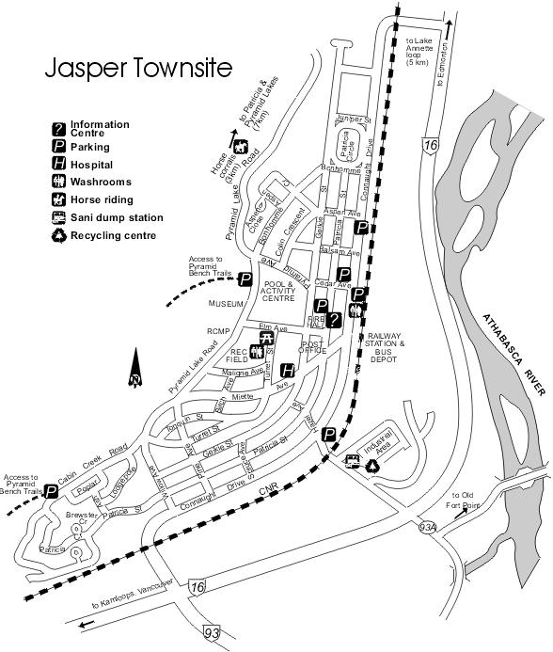
- Pyramid Bench area, many easily accessible hiking trails and lakes
- Lac Beauvert, Lakes Annette and Edith, popular picnicking and hiking spots
- Old Fort Point, great views and the starting point for an extensive trail network
- Jasper Yellowhead Museum and Archives
- Jasper Activity Centre and Aquatic Centre
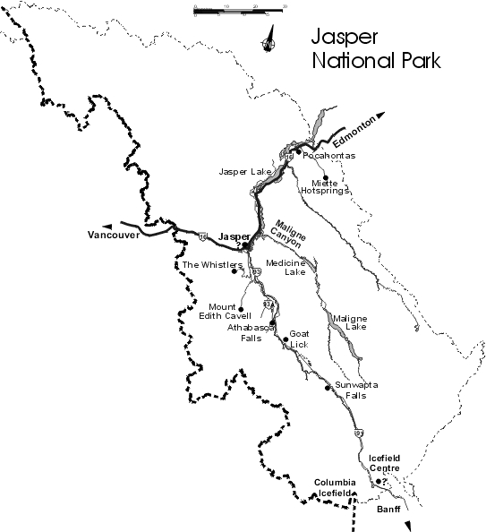
Okanagan Valley: (First night): Dry desert-like in summer
- Okanaga wine festival
- Winery, fruit, orchard, vineyard
- Water, Lake
- Kelowna: the biggest city in valley
  - Cetner of a vast fruit-, vegetable-, and wine-growing area
  - Face the Okanaga Lake
  - Bernard street:商業中心
  - City Park
  - Waterfront Park
  - B.C. orchard industry museum, Tue ~ Sat
    - 水果工業博物館
    - Wine museum
  - Winery:
    - Calona wines: the biggest and oldest
    - Quail’s Gate Estate: ice wine, tour everyday
Kootenay Valley:
- Mining
- River transport => head warter of the vast Coloumbia river, Columbia Lake
- Ranching
- Mount Revel Stoke National Park
  - Revelstoke: root city
    - Touring the Dams: Coloumbia Dams
    - Revelstoke Dame: self-guided tours
    - Visitor Center
    - Mica Dam
  - N.P.
    - To the high country and alpine meadows=> drive up to Mount Revelstoke: great view of Columbia river and the peak of glacier => Balsam Lake(hiking trail)=>shuttle bus to top
    - Hiking trail:
      - Eagle Knoll Trail, Parapets: less than an hour
      - Eva Lake trails: 3.7 Km
- Glacier National Park: 冰河冰原: 14% under permanent snow peak, craggy peaks and hiking trails leading to wildflower
  - Sign up for ranger-led interpretewe hikes as well
    - Head quarter.
  - Golden: 90 Minutes drive from five national parks: mountain time zone
Canadian Rockies:
- Animals:
  - Bighorn sheep
  - Mountain goats
  - Elk
  - Softeyed deer
  - Lumbery moose
  - Coyotes
  - Lynx
  - Wolves
  - bears
- Bnaff: finest mountain scenery, expensive and crowded
  - Mountain lakes, flower-spangled meadows, spirelike peaks, abundant wildlife
  - Bnaff town
  - Lake Louise
  - Icefield parkway
    - Coloumbia Icefields
  - Canmore: east of Bnaff
    - Peak of three sisters mountain
- Jasper: finest mountain scenery, expensive and crowded
- Yoho
- Waterton Lake National Park
- Calgary
  - Calgary museum
  - 1988 winter Olympic
  - Stampede park
  - Calgary Tower
  - Calgary Zoo, botanical garden & prehistoric park
  - Glenbow museum for culture of western Canadian
  - Heritage park historical village
  - Olympic hall of fame and museum
- Edmonton
  - Capital
  - West Edmonton mall: Dolphin, biggest mall in the world

