CS536 Lecture 4
Thursday 29 January 2015

Reminders:
- P1 Part 1 solution on website.
- P1 Part 2 due 11 PM Monday night (Feb 2).
- Reading up
Last class:

- Finite State Machines
- Formal definition
- Deterministic FSMs and non-deterministic FSMs

Today:
- Finish NFA → DFA conversion
- Regular Expressions

NFA Review

Potentially multiple edges with the same label leaving a statements.

Transitions without consuming input.

Example: NFA that accepts strings of length divisible by 2 or 3:
(Surprising?) Claim: DFAs are just as powerful as NFAs

In other words, the collection of languages DFAs can accept is the same as the one NFAs can accept.

Intuition of proof:

- Show that every NFA can be modelled by a DFA (every DFA is already an NFA).
- Do this by building a DFA that tracks the set of states the NFA could be in.
- Add an edge from a state α (α is some set of states of the original NFA) on character c to state β if β represents the union of states that all states in α could possible transition to on character c.
- Cardinality of DFA: at most 2^{|S|}, therefore still finite. Why 2^{|S|}?

Example: An FSM that accepts strings composed of 0s and 1s, and where the third last character is 0.

DFAs are equal in power to NFAs: Dealing with ɛ-transitions

ɛ-closures:
Regular Expressions

Concept:

Operands:

Operators and precedence:

Conventions:

Examples of Regular Expressions

Single line comments in C/Java:

Hex literals:

FORTRAN real literals:

Examples (cont'd)

C/C++ identifiers: Consider the following

(letter | '_')+(letter | digit | '_')*

(letter | '_')(letter*|'_'|digit*)

What regular expression defines the regular language accepted by this FSM:

MATLAB quoted strings:

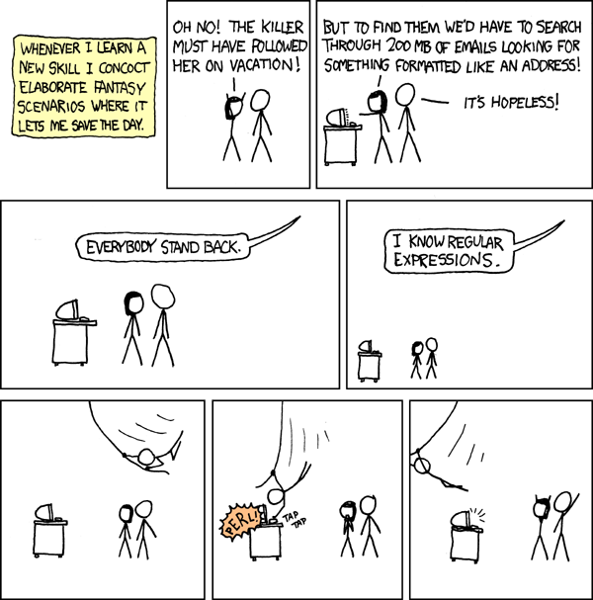
Regular Expressions

http://xkcd.com/208/
Regular Expressions to Scanners

Big picture of scanner generators:

Input:

Step 1:

Step 2:

Step 3:

Step 4:

Step 1: Regular Expression to NFA

Literals and the empty string:

Alternation A|B:

Catenation AB:

Kleene closure A*:

Step 2: NFA to DFA

Why DFA?

Step 3: DFA minimization

Step 4: Generate code using table-driven technique

Actions

FSMs only check for membership. A scanner needs to:

Types of actions:

Example: Pascal identifiers

eof symbol
Our first (full) Scanner

Consider a language consisting of two simple statements:

- Assignments: ID = expr
- Increments: ID += expr

where expr is of the form

- ID + ID
- ID ^ ID
- ID < ID
- ID <= ID

and identifiers ID follow C/C++ conventions.

Tokens:

Token | Regular Expression
ASSIGN | “=”
INCR | “+=”
PLUS | “+”
EXP | “^”
LT | “<”
LEQ | “<=”
ID | (letter|'_')(letter|digit|'_')*

