CS536 Lecture 3
Tuesday 27 January 2015

Reminders:
- P1 Part 1 due tomorrow night (no late submissions), Part 2 due Feb 2.
- HW1 assigned, due next Tuesday.
Last class:

- Phases of a Compiler (synthesis)
- Finite State Machines

Today:
- Finite State Machines
- Formal definition
- Deterministic FSMs and non-deterministic FSMs
- Regular Expressions

Last Time

(Synthesis) Phases of a Compiler

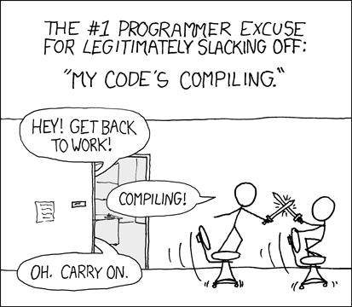

Finite State Machines
Formal Definition

An FSM is a 5-tuple (S, Σ, δ, s₀, F) where

S:

Σ:

δ:

s₀ ∈ S:

F ⊆ S:

An FSM is defined to accept a string _________________________ iff

Error situations:

Example: Hex Literals (cont'd)

Recall our FSM:

Formal definition:

S:

Σ:

s₀:

F:

δ: state transition table

 | 0 | 1-9 | a-f | A-F | x | X | l | L
s₀
s₁
s₂
s₃
s₄
s_{e}

Coding a more generalized FSM

Using a state transition table:

This works provided the FSM is deterministic.

Deterministic and non-deterministic FSMs

Deterministic: No state has more than one outgoing edge with the same label.

Non-deterministic:

- States can have more than one edge with the same label.
- Edges may be labelled with the empty string ɛ.
- If a string yields any path through the machine to a final state, accept.

Example: An FSM that recognizes keywords for, if, and int

Example: Hex literals in Java

Why NFAs?

Compactness:

- NFA that accepts strings ending in 101:

- NFA accepting strings composed of 0s and 1s where the fifth last digit is 1.

- NFA accepting all strings over {a, b, c} that are missing at least one letter.
- NFA that accepts strings where the length is divisible by 2 or 3

Using an NFA

At each step, keep track of set of possible states, and the set of states the machine might transition to.

Example:

(Surprising?) Claim: DFAs are just as powerful as NFAs

In other words, the collection of languages DFAs can accept is the same as the one NFAs can accept.

Intuition of proof:

- Show that every NFA can be modelled by a DFA (every DFA is already an NFA).
- Do this by building a DFA that tracks the set of states the NFA could be in.
- Add an edge from a state α (α is some set of states of the original NFA) on character c to state β if β represents the union of states that all states in α could possible transition to on character c.
- Cardinality of DFA: at most 2^{|S|}, therefore still finite. Why 2^{|S|}?

Example: An FSM that accepts strings composed of 0s and 1s, and where the third last character is 0.

DFAs are equal in power to NFAs: Dealing with ɛ-transitions

ɛ-closures:

