CS536 Lecture 6
Thursday 5 February 2015

Reminders:
- P2 assigned.
- HW2 due next Tuesday.
- Reading
Last class:

- Full Scanner
- JLex

Today:
- Limitations of Regular Expressions
- Context-Free Grammars
- Definition
- Examples

Homework 1
More on JLex

Integrating with Java CUP

Using states in JLex

Identifying keywords

Token class hierarchy
Limitations of Regexes

Regexes are a fine tool to model tokens of a language. However, they cannot capture “structure.”

Matching parentheses: A language L = {(^{x} )^{x} where x > 1} cannot be specified using regular expressions.

Suppose it could …

Limitations of Regexes (cont'd)

Specifying structure:

X = Y + Z

ID ASSIGN ID PLUS ID

What order of operations though?

We need more ...
Chomsky Hierarchy of Languages

Class Power Efficiency

Context-Free Grammars (CFGs)

- A set of (recursive) rewriting rules to generate patterns of strings
- Envision a parse tree that keeps structure

Example of a CFG rule:

S → ( S ) | ϵ

rewrite a symbol S to be surrounded by parentheses OR the empty string.

Diagram:

CFGs recognize the language of these types of trees where all leaves are terminal symbols.

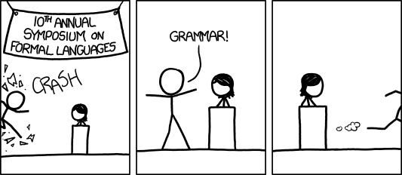
[audience looks around] 'What just happened?' ' There must be some context we're missing.'

http://xkcd.com/1090/

Formal Definition

A CFG is a 4-tuple (N, Σ, P, S):

N:

Σ:

P:

S:

Production Rule Syntax

LHS → RHS

Single nonterminal → expression (sequence of nonterminals and terminals) or empty string

A single nonterminal can appear on the LHS of several different rules. Shorthand notation:

Nonterminal → expression₁ | expression₂ | ϵ

Derivations

“Current Sequence”

To derive a string (of terminals):

- Initialize the Current Sequence to the start symbol
- Repeat:
- Find a nonterminal X in the Current Sequence
- Find a production X → α
- Apply the production: replace X in the Current Sequence with α
- Until there are no more nonterminals in the current sequences

We'll use ⇒ for derives (in one step)
⇒+ for derives in one or more step
⇒* for derives in zero or more step

Example Grammar

Productions:

(1) Prog → BEGIN Stmts END
(2) Stmts → Stmts SEMICOLON Stmt
(3) | Stmt
(4) Stmt → ID ASSIGN Expr
(5) Expr → ID
(6) | Expr PLUS ID

Terminals:

Nonterminals:

Start:

Example Derivation and
Using a Parse Tree for Visualization

Language of a CFG

Set of sequences of terminals that can be derived from the start nonterminal.

L(G) = { w | S ⇒+ w, S is the start nonterminal and
w is a sequence of terminals or ϵ}

CFGs for Syntax Definition

CFG productions define the syntax of a language. We used the Backus-Naur Form (BNF) above.

We're mostly interested in going in the other direction though. We'll get there ...

