Example Function
Functions

We begin by considering functions. Using the Matlab editor, copy the following two lines of script and paste them into a Matlab script file. Save the file with the name squarePlus1.m in a directory.

function b = squarePlus1( a )

b = a.^2 + 1 ;

This function takes the input, also called the argument, and squares it and then adds 1 to the value. This example of a function is so simple that one usually would not make this function, but it shows clearly what a function does.

This simple function has the two basic parts of the function. The first line is the declaration of the function giving the name of the function along with the names of the input and output. The second line computes the function.

To make sure that the function is available, use the ls command from the command window. You should see the file squarePlus1.m in the list of files. If it is not listed, use the command pwd to find out which directory Matlab is using, and then use the command cd to change to the directory in which you have saved squarePlus1.m.

In the command window enter the following commands

squarePlus1( 2 )

z = squarePlus1( 5 )

g = 3
h = squarePlus1( g )

In the first call to the function, Matlab assigns the value returned by squarePlus1() to the default variable ans. In the second call, the variable z is assigned the result returned from squarePlus(). The third and final call shows how you can use variables in calling a function.

Notice that in the command in from squarePlus() we have used the .^ operation instead of the ^ operator. The reason that the exponentiation has the dot before the carat is that this function will handle vector inputs. Check this with the following commands.

squarePlus1( [ 2 5 7 ])

v = squarePlus1( [ pi pi/2 exp(1) ])

As a more useful function consider the next function.

function e = expintApprox( x)

% This function computes an approximation to the
% exponential integral
% e ~ integral from x to infinity of exp(-t)/t .

% Use the log() plus a polynomial for small values of x.
if x < 1
e = -log(x) - 0.57721566 + x.*(0.99999193 ...
- x.*(0.24991055 – x.*(0.05519968 ...
- x.*(0.00976004 – x.* 0.00107857 )))) ;

% Use a ratio of polynomials for larger values of x.
else
e = exp(-x).* (0.250621 + x.*( 2.334733 + x )) ./ ...
((1.681534 + x.*( 3.330657 + x )).*x ) ;
end

This Matlab function, expintApprox( ), computes a good approximation to the exponential integral function given by

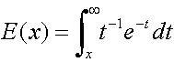

Notice that the function depends on x, and is computed by integrating another function from x to infinity. The exponential integral function arises in a number of engineering and scientific applications.

Again, take some time to notice each part of the function script. There is the first line that specifies that this is a function and gives the name of the function. It also specifies the inputs and outputs.

The comments are not essential, but are very useful in non-trivial functions. They help us understand what the function does and gives other information.

The lines that compute the function are next.

Matlab has a built-in function that computes the exponential integral function to full precision and it is called expint( ). The approximation we give is quite accurate, but not quite as good as the Matlab function.

Copy and paste the above Matlab commands onto the file expintApprox.m. Test this function on the vector [ 0.5 , 1.5 ]. Compare the values returned by our approximation with the values returned by expint( ) for these same values. You may want to change the format with the command format long so that you see the difference between the two functions. You can enter the command format short to restore the default format.

The next script plots the functions and the difference between the functions. Notice that the difference is less than 10⁻⁵. The functions should be indistinguishable to plotting accuracy.

clear
clf

x = 0.1 : 0.2 : 5 ;

for k = 1: length(x)

yA(k) = expintApprox( x(k) ) ;

end

yB = expint( x ) ;

yD = yB - yA ;

subplot(2,1,1), plot( x, yA , 'r', x, yB, 'b' )
subplot(2,1,2), plot( x, yD )

As an exercise, you should write a function that does the following:

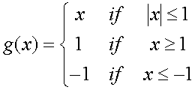

We will call this function ‘ramp’. A plot of the function is shown in the next figure.

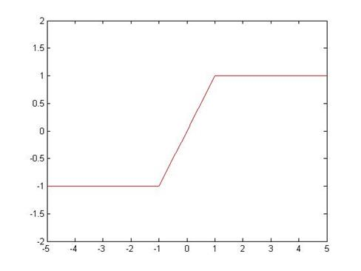

Write a function ramp() that computes this function. You can use the following script to test whether your function computes the function correctly. The plot should look like that in the figure.

%% Ramp test
clear
clf

x = -5: 0.2 : 5 ;
for k = 1: length(x)
y(k) = ramp( x(k) ) ;
end

plot( x, y, 'r' )
axis( [ -5 5 -2 2 ] )

