Example Piece-wise Polynomials
We next consider a function that is defined as a piece-wise polynomial, that is, it is defined as different polynomials in different intervals. We will encounter these functions again in the section on interpolation. The function we consider first is given by the formula
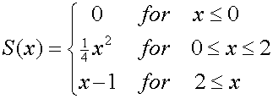
We consider how to implement this mathematical function as a Matlab function. Here is one way to do this for a scalar variable x:
function y = S310scalar(x)
% This function computes a piece-wise polynomial function.
if x <= 0.
y = 0. ;
elseif x <= 2.
y = 0.25*x^2 ;
else
y = x - 1 ;
end
All the code for this function should be placed in a file named S310scalar.m. Notice that this function has the same basic structure as the function error_approx: the first line states that this is a function file and what the inputs and output are called, following this there is a comment to give information about this function, then follows the actual computation of the function. The script checks successive ranges for x, and then computes the appropriate value for y.
Having defined this function, we can now use it in any other program. For example,
x = -1: 0.1 : 3 ;
for k = 1 : length(x)
y(k) = S310scalar( x(k) ) ;
end
plot(x, y)

