Correlation & Linear Regression on the  Casio FX-300ES | 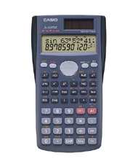
To Enter Data:
- Press STAT (SHIFT then 1)
- Press 2: A+BX
- Enter the x-values into the X column.
- Enter the y-values into the Y column.

To See the Statistics:
- Press STAT (SHIFT then 1)
- Press 7: Reg
- Choose the value you would like to see:
  - Correlation: Press 3: r
  - Slope: Press 2: B
  - y-intercept: Press 1: A

To Clear All Data:
Press MODE while entering data.

