Correlation & Linear Regression on the  Casio FX-300MS | 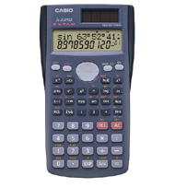
To Enter Data:
- Press MODE then 3 (REG) then 1 (Lin).
- Enter each data pair.
  - Enter the x-value. Press , (comma).
  - Enter the corresponding y-value. Press M+.

To See the Statistics:
- Press S-VAR (SHIFT then 2).
- Press the right arrow twice.
- Choose the value you would like to see:
  - Correlation: Press 3 (r).
  - Slope: Press 2 (B).
  - y-intercept: Press 1 (A).
- Press =.

To Clear All Data:
Press MODE while entering data.

