Correlation & Linear Regression on the  TI-30X IIS, TI-30X IIB,  or TI-34 II | 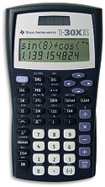
To Enter Data:
- Press STAT (2nd then DATA).
- Use the arrows to underline 2-VAR. Press ENTER.
- Press DATA.
- Enter each data pair.
  - Enter the x-value. Press the down arrow.
  - Enter the corresponding y-value. Press the down arrow.

To See the Statistics:
- Press STATVAR.
- Use the arrows to underline the statistic you would like to see. The value of that statistic is shown on the screen.
  - r = correlation
  - a = slope of the least-squares regression line.
  - b = y-intercept of the least-squares regression line.

To Clear All Data:
- Press STAT (2nd then DATA).
- Use the arrows to underline CLRDATA. Press ENTER.

