Correlation & Linear Regression on the TI-34 Multiview | 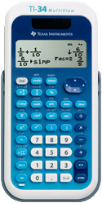
To Enter Data:
- Press DATA.
- Enter your data for x in the column L1.
- Enter your data for y in the column L2.

Slope, y-Intercept, and Correlation:
- Press STAT (2nd then DATA).
- Select 2: 2-Var Stats. Press ENTER.
- Choose L1 for xData and L2 for yData.
- Press ENTER. Scroll down to see the statistics.
  - a = slope
  - b = y-intercept
  - r = correlation

To Clear All Data:
- Press DATA.
- Press DATA again.
- Select 4: Clear ALL. Press ENTER.

