Correlation & Linear Regression on the  TI-82, TI-83 Plus, or  TI-84 Plus |  | 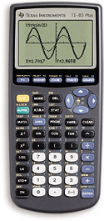  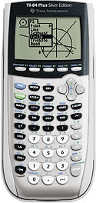
To Enter Data:
- Press STAT.
- Select 1: Edit. Press ENTER.
- Enter your data for x in the column L1.
- Enter your data for y in the column L2.

To See the Statistics:
Do this ONCE:  - Press EXIT (2nd then MODE).  - Press CATALOG (2nd then 0).  - Scroll down to find DiagnosticOn.  - Press ENTER.  - Press ENTER. | Slope, y-Intercept, and Correlation:  - Press STAT.  - Arrow over to CALC.  - Select 8: LinReg (a+bx). Press ENTER.  - Pres L1 (2nd then 1).  - Press , (comma).  - Press L2 (2nd then 2).  - Press ENTER.  - a = y-intercept  - b = slope  - r = correlation
To Clear All Data:
- Press STAT.
- Select 1: Edit. Press ENTER.
- Arrow up to highlight L1.
- Press CLEAR.
- Press ENTER.

