Correlation & Linear Regression on the TI-86 | 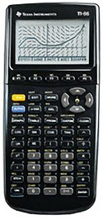
To Enter Data:
- Press STAT (2nd then +).
- Press F2 – EDIT.
- Enter your data for x in the column xStat.
- Enter your data for y in the column yStat.

To See the Statistics:
- Press EXIT to return to the home screen.
- Press STAT (2nd then +).
- Press F1 – CALC.
- Press F3 – LinR.
- Type (.
- Press LIST (2nd then -).
- Press F3 – NAMES.
- Press F2 – xStat.
- Type , (comma).
- Press F3 – yStat.
- Type ).
- Press ENTER.
  - corr = Correlation
  - b = Slope
  - a = y-intercept

To Clear All Data:
- Press STAT (2nd then +).
- Press F2 – EDIT.
- Arrow up to highlight xStat.
- Press CLEAR.
- Press the down arrow.

