Correlation & Linear Regression on the  TI-BAII Plus | 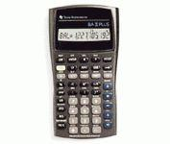
To Enter Data:
- Press DATA (2nd then 7)
- Press 2nd then CE/C to clear all the data.
- Enter each data point.
  - Enter the x-value.
  - Press ENTER.
  - Press the down arrow.
  - Enter the y-value.
  - Press ENTER.
  - Press the down arrow.
  - Enter the rest of the data points.

To See the Statistics:
- Press 2nd then STAT
- Press 2nd then SET until LIN is displayed
- Press the down arrow to see the variables:
  - Correlation = r
  - Slope = b
  - y-intercept= a

