Mean & Standard Deviation on the Casio FX-115MS |  | 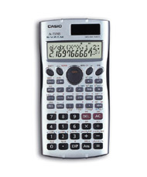
To Enter Data:
- Press MODE, MODE, then 1.
- Enter each data value.
  - Enter the number.
  - Press M+.

To See the Statistics:
Mean:  - Press S-VAR (SHIFT then 2).  - Press 1 ().  - Press =. | Standard Deviation:  - Press S-VAR (SHIFT then 2).  - Press 3 (x).  - Press =.
To Clear All Data:
- Press SHIFT then CLR.
- Press 1 (Scl = Stat Clear).

