Mean & Standard Deviation on the Casio FX-260 |  | 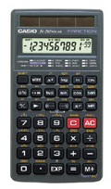
To Enter Data:
- Enter each data value.
  - Enter the number.
  - Press M+.

To See the Statistics:
Mean: Press (SHIFT then 7). | Standard Deviation:  Press (SHIFT then 9).
To Clear All Data:
- Press MODE then . (period).
- Press Scl (SHIFT then AC).

