Mean & Standard Deviation on the  TI-30X IIS, TI-30X IIB, or TI-34 II | 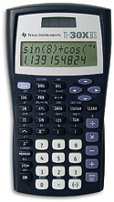
To Enter Data:
- Press STAT (2nd then DATA).
- Use the arrows to underline 1-VAR. Press ENTER.
- Press DATA.
- Enter each data value.
  - Enter the number. Press the down arrow.
  - Enter the frequency (defaulted to 1). Press the down arrow.

To See the Statistics:
- Press STATVAR.
- Use the arrows to underline the statistic you would like to see. The value of that statistic is shown on the screen.
  - = mean
  - Sx = standard deviation

To Clear All Data:
- Press STAT (2nd then DATA).
- Use the arrows to underline CLRDATA. Press ENTER.

