Mean & Standard Deviation on the TI-30X or TI-30Xa |  | 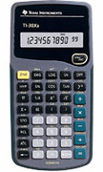  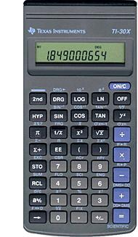
To Enter Data:
Enter each data value. (Your screen will show a count of them.)
- Enter the number.
- Press .

To See the Statistics:
Mean: Press (2nd then ). | Standard Deviation:  Press (2nd then ).
To Clear All Data:
Turn the calculator off then on again.

