Mean & Standard Deviation on the  TI-30XS | 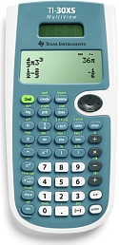
To Enter Data:
- Press DATA.
- Enter each data value in list L1 .
  - Enter the number. Press the down arrow.
  - Continue entering all the numbers.
  - Press ENTER when done.

To See the Statistics:
- Press STAT (2nd then DATA).
- Select 1:1-Var Stats. Press ENTER.
- Make sure the list L1 is highlighted with frequency one.
- Press ENTER. Arrow down to see the statistics.
  - = mean
  - Sx = standard deviation

To Clear All Data:
- Press DATA, then DATA again.
- Select 4:Clear ALL. Press ENTER.

