Mean & Standard Deviation on the TI-34 Multiview | 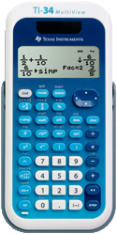
To Enter Data:
- Press DATA.
- Enter your data in the column L1.

To See the Statistics:
- Press STAT (2nd then DATA).
- Select 1: 1-Var Stats. Press ENTER.
- Choose L1 for data and ONE for frequency.
- Press ENTER. Scroll down to see the statistics.
  - = mean
  - Sx = standard deviation

To Clear All Data:
- Press DATA.
- Press DATA again.
- Select 4: Clear ALL. Press ENTER.

