Mean & Standard Deviation on the TI-82, TI-83 Plus,  or TI-84 Plus | 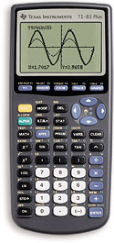  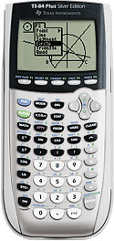
To Enter Data:
- Press STAT.
- Select 1: Edit. Press ENTER.
- Enter your data in the column L1.

To See the Statistics:
- Press STAT.
- Arrow over to CALC.
- Select 1: 1-Var Stats. Press ENTER.
- Press LIST (2nd then STAT).
- Select the list your data is in (L1). Press ENTER.
- Press ENTER.
  - = mean
  - Sx = standard deviation

To Clear All Data:
- Press STAT.
- Select 1: Edit. Press ENTER.
- Arrow up to highlight L1.
- Press CLEAR.
- Press ENTER.

