Mean & Standard Deviation on the TI-85 | 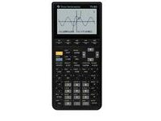
To Enter Data:
- Press STAT.
- Press F2 – EDIT.
- Press F1 – xStat.
- Press ENTER.
- Press F2 – yStat.
- Press ENTER.
- Enter the first number in your data list.
- Press ENTER, ENTER. (To get past the y-value.)
- Enter the next number and press ENTER, ENTER.
- When you are done entering data, press EXIT, EXIT.

To See the Statistics:
- Press STAT.
- Press F1 – CALC.
- Press ENTER, ENTER.
- Press F1 – 1-VAR.
  - = mean
  - Sx = standard deviation

To Clear All Data:
- Press STAT.
- Press F2 – EDIT.
- Press ENTER, ENTER.
- Press F5 – CLRxy.

