Mean & Standard Deviation  on the TI-86 | 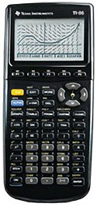
To Enter Data:
- Press STAT (2nd then +).
- Press F2 – EDIT.
- Enter your data in the column xStat.

To See the Statistics:
- Press EXIT to return to the home screen.
- Press STAT (2nd then +).
- Press F1 – CALC.
- Press F1 – OneVa.
- Type (.
- Press LIST (2nd then -).
- Press F3 – NAMES.
- Press F2 – xStat.
- Type ).
- Press ENTER.
  - = mean
  - Sx = standard deviation

To Clear All Data:
- Press STAT (2nd then +).
- Press F2 – EDIT.
- Arrow up to highlight xStat.
- Press CLEAR.
- Press the down arrow.

