Mean & Standard Deviation on the TI-BAII Plus | 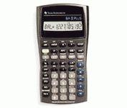
To Enter Data:
- Press DATA (2nd then 7)
- Press 2nd then CE/C to clear all the data.
- Enter each data value. (Your screen will show a count of them.)
  - Enter the number.
  - Press the down arrow twice.

To See the Statistics:
- Press 2nd then STAT
- Press 2nd then SET until 1-V is displayed
- Press the down arrow to see the variables:
  - Mean =
  - Standard Deviation = Sx

