NMI Build System

What is NMI Build System all about?

The purpose of the NSF Middleware Initiative (NMI) is to develop, deploy and sustain a set of reusable and expandable middleware functions that benefit many science and engineering applications in a networked environment. Robust middleware services are especially important for enhancing scientific productivity and for facilitating research and education collaborations through sharing of data, instruments, and computing resources.

Downloading the Build System

Setting environment for CVS

Make sure your environment has following variables set. Do not forget to replace the string <login name> with your actual login name.

$> CVSROOT=:ext:<login name>@chopin.cs.wisc.edu:/p/condor/repository/nmi
$> CVSROOTPREFIX=:ext: :<login name>@chopin.cs.wisc.edu:
$> CVS_RSH=ssh
$> CVS_SERVER=/afs/cs.wisc.edu/u/t/a/tannenba/public/ntcvs
$> SCPPREFIX=:<login name>@chopin.cs.wisc.edu:

Now set the ssh keys so ssh commands to your normal workstation happen without passwords.

Checking out Build System from CVS

First, you should checkout the software with appropriate tag from the CVS. Unless you are working on VDT or Condor builds you should checkout the software for NMI builds.

For condor-builds:

$> cvs co -r nmibuild_V4_0_0-CONDOR-branch R4_COMMON

For NMI builds:

$> cvs co -r nmibuild_V4_0_0-NMI-branch R4_COMMON

For VDT builds:

$> cvs co -r nmibuild_V4_0_0-VDT-branch R4_COMMON

This will checkout the Build System in directory called nmi_build for either Condor/NMI/VDT. In the NMI world this is called as the “Build Space.” Because the build system “vger.cs.wisc.edu” is outside of the Computer Science Department on the Internet, most who work with a build space will not actually check it out and set it up at this time.

Configuring the Build System

Before you could start using the Build System you should make the required changes to the configuration files. The Build System is fairly easy to understand and configure.

The entire Build System configuration is controlled by the set of configuration files explained below –

- COMPONENTS

This file contains list of component(s) you want to build. The example below configures the Build System to build Globus, MyProxy and GSISSH. Component(s) that are commented will not be considered for build.

[parag@vger nmi_build]$ cat COMPONENTS
globus "2"
#globusgt3 "4"
#nws "6"
#kx509 "8"
myproxy 9
gsissh "10"
#gridsolve "11"
#gpt "12"
#condor "15"
#globussrc "17"
#mpichg2 "18"
#pyglobus "19"
#uberftp "20"
#all "21"
#testjob
[parag@vger nmi_build]$

- HOME

This file should contain a single line where the Build System has been checked out. If you have checked out the sources in directory /space/wspaces/parag/nmi-branch then –

[parag@vger nmi_build]$ cat HOME
/space/wspaces/parag/nmi-branch/nmi_build
[parag@vger nmi_build]$

- CONTROL

Only uncomment the “Std Contrib Build” line while you want to build the component(s). Comment rest of the lines of the files unless you know what you are doing.

[parag@vger nmi_build]$ cat CONTROL
#4 "Clean FTP Tree"
#5 "Prebuild"
#6 "Build"
#7 "Build FTP Tree"
8 "Std Contrib Build"
#9 "Deploy"
#11 "Automater Verify"
#12 "VDT Build"
#13 "Build All Bundles"
[parag@vger nmi_build]$

- PLATFORMS
This file contains the list of platforms you want to build your component against. Select the required platforms from the list and comment the rest. You can build your component(s) for more than one platform at the same time. Example below will build the component(s) for Redhat-72 and Redhat-80

[parag@vger nmi_build]$ cat PLATFORMS
linux-x86-rh72
linux-x86-rh80
#linux-x86-rh90
#linux-x86-rh90-isi
#linux-x86-2952
#linux-ia64-rh72
#linux-ia64-sles8
#linux-alpha-rh72
#dux-40f
#dux-51
#solaris-sparc-6
#solaris-sparc-7
#solaris-sparc-8
#solaris-sparc-9
#macosx-102
#hpux-1020
#aix-52
#irix-65
[parag@vger nmi_build]$

- SOURCE_TO_FETCH

This setting instructs the Build System which component(s) specific files to retrieve from the CVS for each build run. If a component is set to build and commented out here either an earlier check out of sources will build or the build will fail. In most cases this will always be same as the list in the COMPONENTS file.

[parag@vger nmi_build]$ cat SOURCE_TO_FETCH
#GPT "Fetch gpt"
GLOBUS "Fetch globus"
#GLOBUSGT3 "Fetch globus"
#GLOBUSBLD "Fetch globus 2_4 3_0 build"
#NWS "Fetch nws"
MYPROXY "Fetch myproxy"
#GRIDCONFIG "Fetch gridconfig"
GSISSH "Fetch gsissh"
#KX509 "Fetch kx509"
#GRIDSOLVE "Fetch gridsolve"
#MPICHG2 "Fetch mpich-g2"
#CONDOR "Condor - LoS build"
#PYGLOBUS "Fetch PyGlobus"
#UBERFTP "Fetch UberFTP"
[parag@vger nmi_build]$

- VERSION

This file contains the version string for the component binaries produced. For example to build the component(s) for NMI-R4 the file should read –

[parag@vger nmi_build]$ cat VERSION
NMI-4.0
[parag@vger nmi_build]$

Building Component(s)

You have checked out the source, configured the Build System and the stage is set to build your component(s). To start building the component(s) you need to execute “master_build.pl” but before doing that lets understand the available options.

Following screen demonstrates the options available to the user.

[parag@vger nmi_build]$ ./master_build.pl –-help
Usage: master_build.pl [-h/--help] [-n/--notify=s] [-t/--type=s]
Options:
[-h/--help] Print this message
[-n/--notify=s] comma separated notify list
[-t/--type=s] build type with nmi as default
[-c/--cvs] Directed cvs access
[-m/--module=s] Module to fetch if cvs set
[-g/--get=s] Tag to get if cvs set
[-s/--sleep=s] Sleep time between build submits
[-p/--package=s] Package choices for globus
[ all, prepatch, prepatchplus, patch,
patchplus, postpatch, postpatchplus,
prebuilt ]
[-b/--build=s ] Do we build it or not
[parag@vger nmi_build]$

- --type=<nmi|vdt|edg> [Default: nmi]
If you are building NMI component(s) you do not need to specify the –type option. By default the builds are configured to be of type nmi.

- --notify=<user@domain>
If you would like a notification once the build has finished set this option

- --cvs

- --module

- --get

- --sleep=<x> [Default: 120secs]

Building components is disk intensive task. If you build several components at the same time it may lead to thrashing and slowing down your system. So by default we introduce a small delay between building two components.

- --package [Only used with –-type=vdt]
This is an advance option for building Globus available only to the VDT users.

- --build [Default=yes]

If you are building the component(s) for NMI simply enter the following command –

[parag@vger nmi_build]$ ./master_build.pl

Getting the results

You have successfully submitted the build and now you are anxious to see what happened to it. This section explains how to watch the progress of your builds and how to get the results of your builds.

Once you have submitted the build, list the contents of your build space to see what has changed.

[parag@vger nmi_build]$ ls
2881 cron_clean.pl NmiTools.pm
2882 CVS PLATFORMS
2883 CVS_Tags R4patches
2884 dbfix.pl results_2881
aborted_2881 dbkeep.pl results_2882
aborted_2882 dbnote.pl results_2883
aborted_2883 DBTools.pm results_2884
aborted_2884 deploy.pl returnval
adminscripts forwhom.pl returnval.C
autoconf-2.13.tar.gz gpt-autotools.tar.gz scripts
BuildAutoClean.pl HOME SOURCE_TO_FETCH
bundles install.pl std_contrib
comp_fetch_srcs.pl INSTALL_README std_contrib_building.pl
component_gpt_dist.tar.gz interim_results SubmitGen.pm
components Makefile VERSION
COMPONENTS master_build.pl worked_2881
Condor.pm NmiBuildTools.pm worked_2882
CONTROL NmiConfig.pm worked_2883
cron_build.pl nmi_get_tarball.pl worked_2884
[parag@vger nmi_build]$

You will notice new directory created in your build space. Once you submit the build the Build System assigns a unique ID to it and creates a subdirectory with this id in your build space. The above example shows the results after submitting four builds which have ids 2881, 2882, 2883, and 2884. Each of these directories is termed as “build directory”. All the logs for your builds are available in the build directories.

Watching the progress of builds

There are two places to find out the progress of your build. The first place is the build directory. As you can see below the build directory contains a lot of information about your build. The log for build activity before the component(s) is built on the different platform can be found in “std_contrib.log” and “comp_fetch_srcs.log”. The build directory contains several subdirectories for the platforms which are available.

[parag@vger nmi_build]$ cd 2882
[parag@vger 2882]$ ls
aix-52 globus.tar.gz linux-x86-rh90 returnval
comp_fetch_srcs.log hpux-1020 linux-x86-rh90-isi solaris-sparc-6
COMPONENTS irix-65 macosx-102 solaris-sparc-7
Condor.pm linux-alpha-rh72 NmiBuildTools.pm solaris-sparc-8
CONTROL linux-ia64-rh72 NmiConfig.pm solaris-sparc-9
CVSSRCS linux-ia64-sles8 nmi_get_tarball.pl SOURCE_TO_FETCH
CVSSRCSVDT linux-x86-2952 NmiStd.pm std_contrib.log
dux-40f linux-x86-rh62 NmiTools.pm VERSION
dux-51 linux-x86-rh72 PLATFORMS winnt-51
extractdir linux-x86-rh80 REQUESTEDPRODUCTS
[parag@vger 2882]$

Once you have submitted the builds you can checkout the progress online by pointing your browser to http://vger.cs.wisc.edu/nbs/summary.php

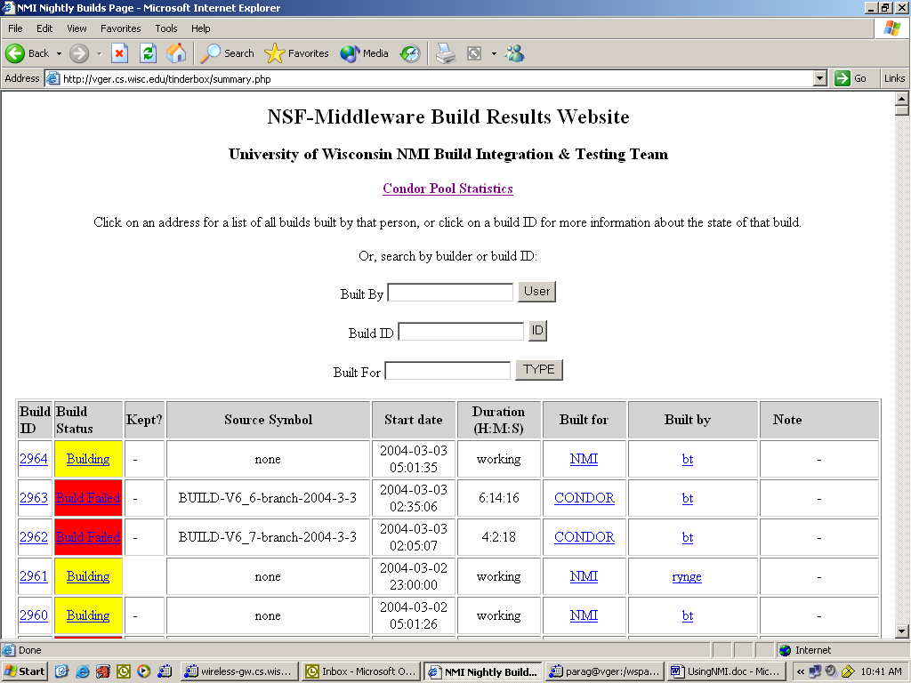

Click on the build id or the build status link to find out more about the build you submitted.

Getting the results of your builds

Once the status of your build has changed to “Passed” or “Build Failed” then to get the result of your build(s) click the status link. This lists the status of the component on the platform(s) you have configured it to build.

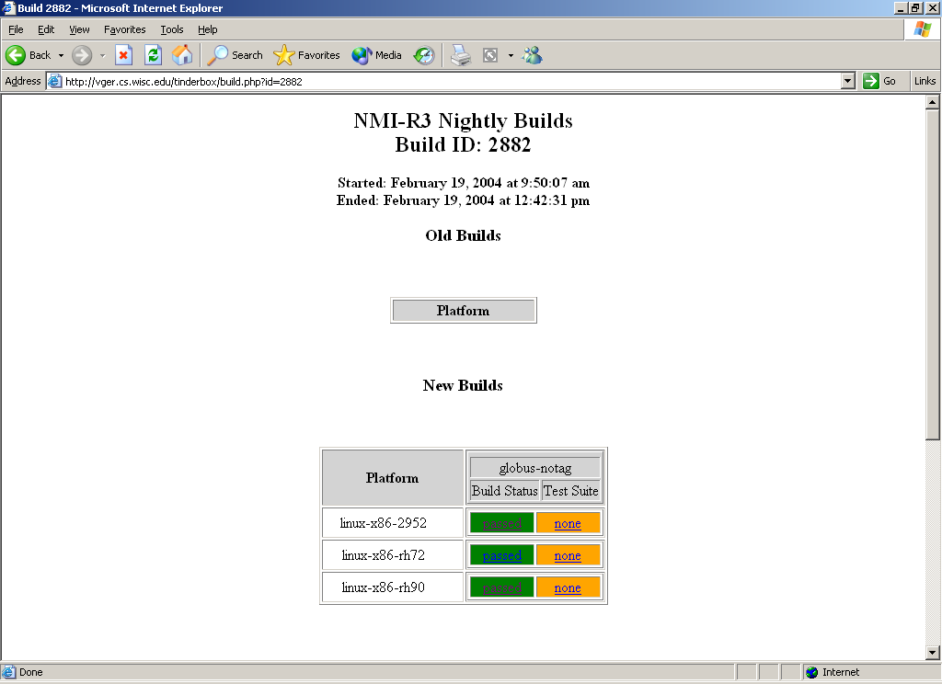

Click the build status of required platform and you will be directed to the results of the build on that platform. The access to the results is password protected. The final page showing the results looks like shown below.

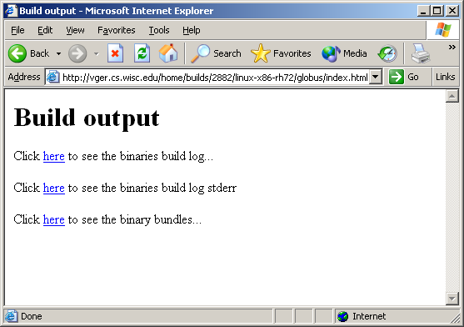

If the build succeeded it will generate the binary bundles. Check the log if everything looks good and there are no harmful warning or error messages. In case there were error messages generated while building your component they will be available to you on this page. This information is also transferred back to you in your build directory.

Building Globus with patches

Create a workspace and checkout the VDT branch for the build system. The following discussion focuses on building Globus with patches for VDT.

Version of Globus that is distributed in VDT is slightly different than from the one distributed by NMI. VDT-Globus includes several patches and bug fixes that have been submitted to Globus (especially by LCG) but have not made into the current release of Globus yet. The earlier versions of NMI didn’t have any mechanism to apply special patches required for VDT. As a result it was required to enhance the NMI build system to insert the patching stage in the middle of the building stage.

NMI build system has been enhanced to incorporate the patching stage based on the build type as shown in the Figure below. The patching stage is optional and fully configurable.

Globus pre-build steps
Globus bundles
$BuildType == NMI
Pre-patching
Patching
Post-patching
$BuildType == VDT
Pre-build
Globus build steps
Figure: Building Globus bundles, the new way

Pre-patching Stage:

In this stage we download the Globus sources from the Globus CVS repository (CVSROOT = “:pserver:anonymous@cvs.globus.org”) and do the other necessary things so that the stage is set for patching the sources. The script that does this task is patches/globus/prepatching.pl.

Patching Stage:

We apply the required patches to the Globus sources. The patches are stored in a predefined location (patches/globus/VDT_patches). One can control which patches should be applied from the list of available patches. It is also possible to configure the patching to apply entirely different set of patches for different build types. The script that does this task is patches/globus/apply_patches.pl. To modify the list of patches edit this file and add the patch information to the variable %patches in the same manner as for other patches. Now modify the variable @vdt_patches to add/remove patches that will be applied before building Globus. Note that merely adding the patch information to %patches will not apply that patch.

Post-Patching Stage:

We collect the patched sources of Globus and keep them ready to be built on different platforms. This stage is executed as script patches/globus/postpatching.pl

Pre-built Stage:

The pre-build stage in this case is reduced to submitting the source code to be built on required platforms to get the patched version of Globus. This stage is executed as script patches/globus/postbuild.pl

Other Enhancements

Apart from inserting the patching stage the scheme was also enhanced to perform the individual stages independently and to store the results of every stage or to start from a required stage and perform the operations till we get the Globus bundles. Thus Pre-Patching, Patching and Post-Patching stages store their output to a known place (in directory interim_results). This output can then be used to start the builds from their subsequent stages. In that case the starting stage of the build will restore the output of the previous known good build stage and start working from there. This is very effective to reduce the time and IO operations required for every Globus build. This is configurable by the parameter --package passed to the builds.

--package can be of following type
prepatch | Only perform the pre-patching stage and store the output
prepatchplus | Start from the pre-patching stage and complete the operations till the end.
patch | Starting from the output of last pre-patching stage, only perform the patching stage and store the output
patchplus | Starting from the output of last pre-patching stage, complete the operations till the end.
postpatch | Starting from the output of last patching stage, only perform the post-patching stage and store the output
postpatchplus | Starting from the output of last patching stage, complete the operations till the end.
prebuilt | Starting from the output of last post-patching stage, complete the operations till the end.
all | This is essentially same as prepatchplus.

